**Report**

**Workshop on Computer Applications**

Lecture Cum Workshop on Computer Applications was organized under placement cell from 20.11.2018 to 22.11.2018. Mr. Ajay Rajput and Mr. Rajat trainer in Hartron, Skill Centre, Jind delivered the extension lectures with the help of PPT.

**Workshop on M. S OFFICE**

A Lecture –cum-workshop on MS Office for Commerce students was organised on 27/11/2018 to 28/11/2018 2018 under placement cell. Mr Ajay Rajput computer Trainer in Hartron skill Centre Jind delivered the lectures He gave the detailed information about MS Office.

**Report**

**Extension lecture**

Two extension lectures were organised on the topics chem draw app and Microsoft Power Point preparation and presentation under placement cell on 15 /01/ 2019, Assistant prof. in Pt. C.L.S GovT. PG college Karnal delivered the lecture with the help of ppt. In first lecture which was on Microsoft PowerPoint prepare preparation and presentation Mr Sukhraj discussed about how to prepare a PowerPoint presentation and the second part how to present our presentation

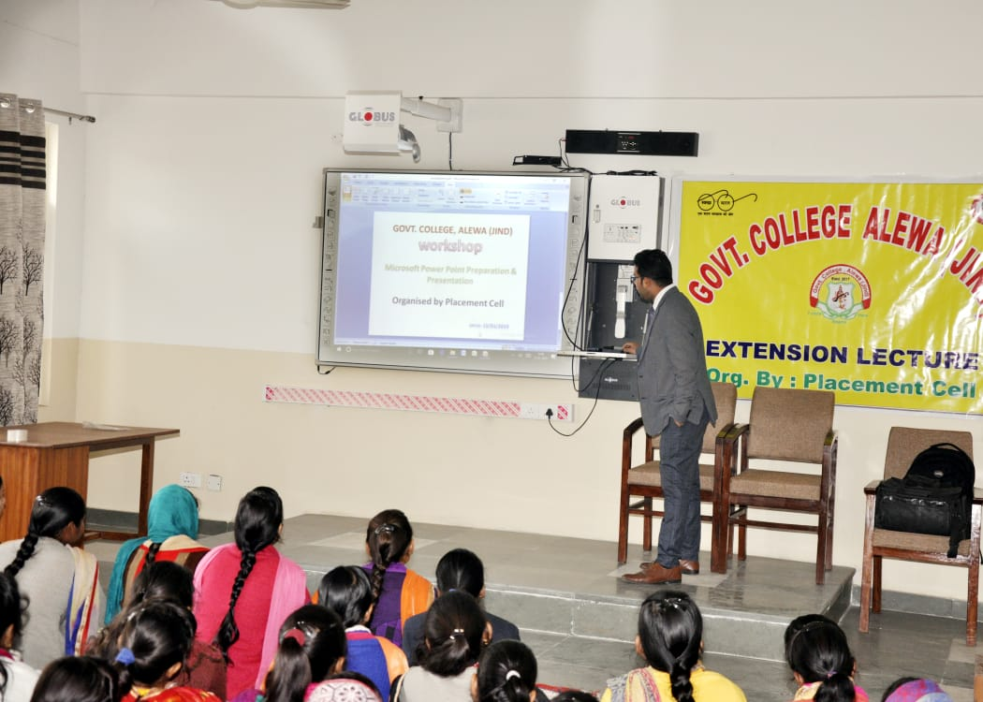

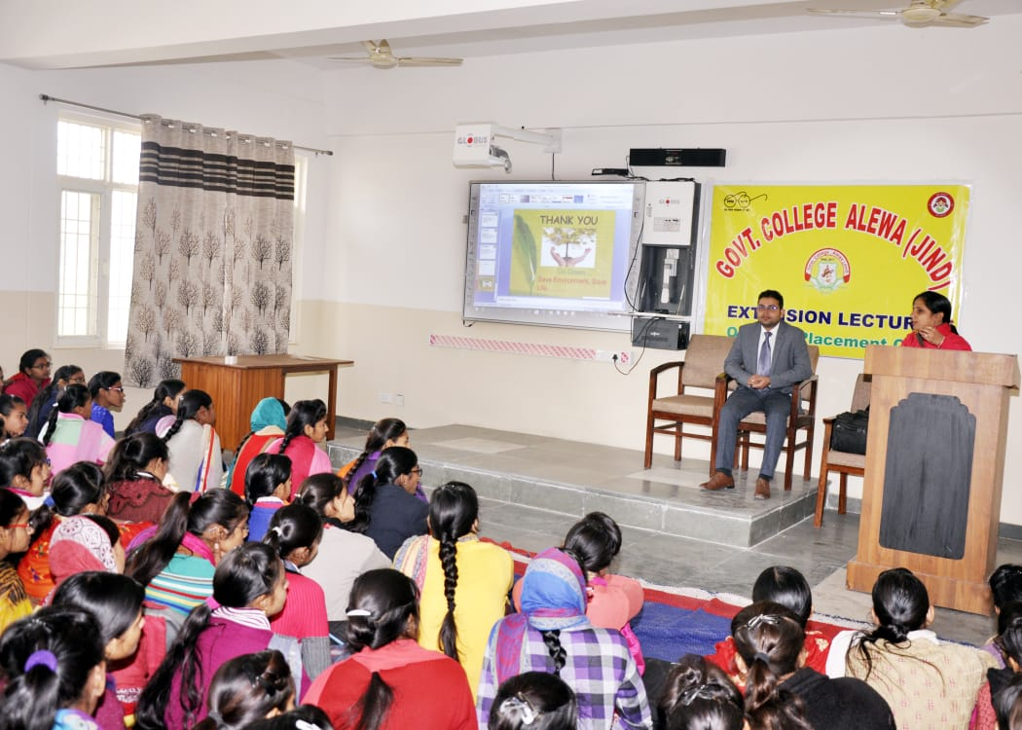

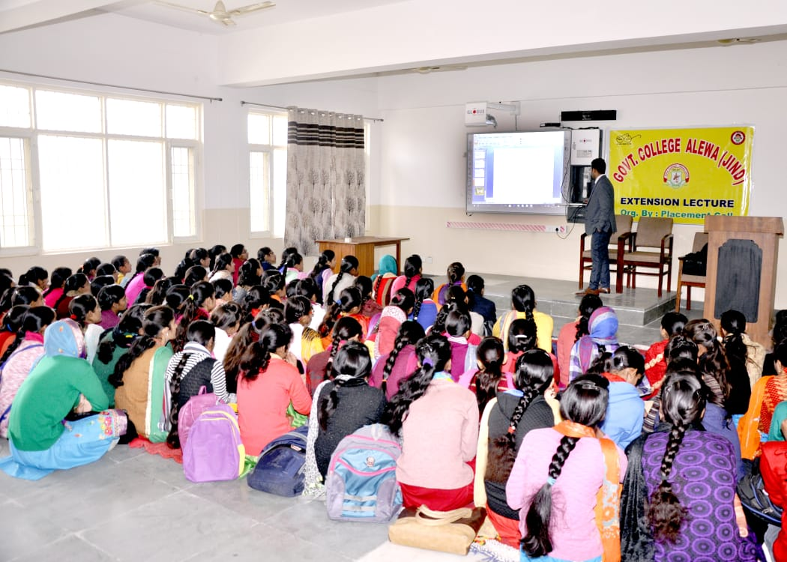

**Report**

**Extension lecture**

An Extension lecture was organised on the topic Scientific methods of mushroom cultivation on 21/01/2019. Dr. J.N.Bhatia, professor plant pathology Krishi Vigyan Kendra Kurukshetra delivered this lecture with PowerPoint . He gave the information about different methods of mushroom cultivation & jobs opportunity in this field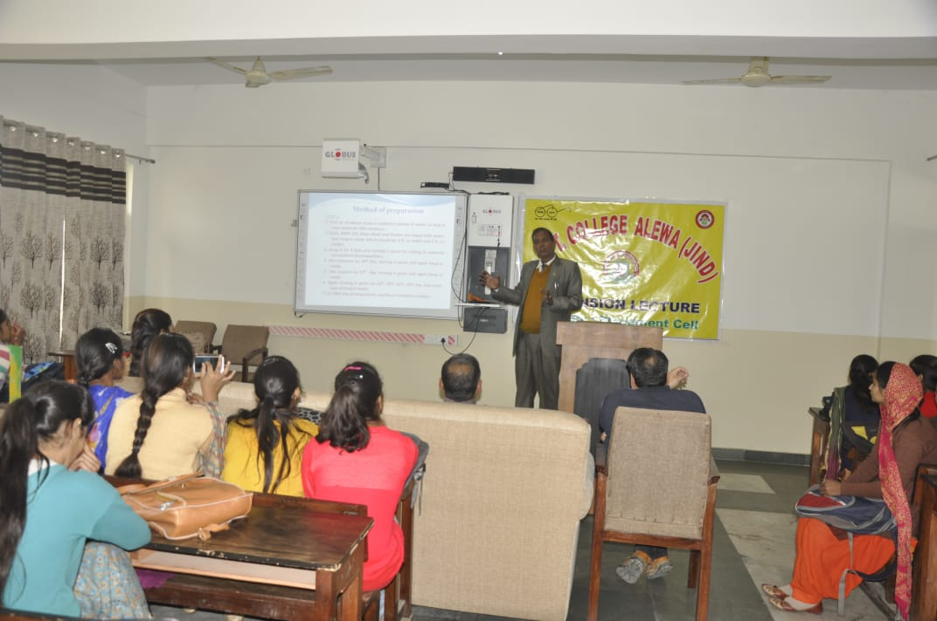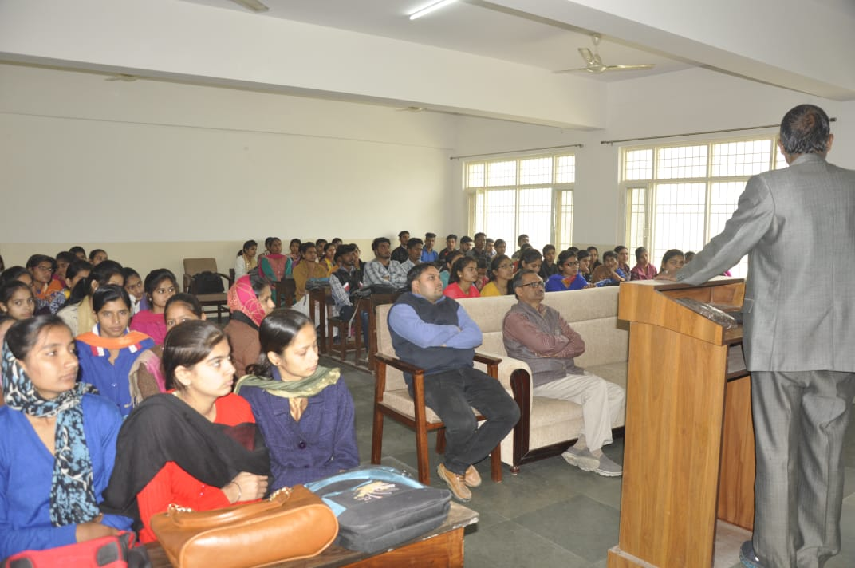

**Report**

**Workshop on Personality Development**

A five-day workshop on Personality Development was organized under placement cell from 30.01.2019 to 08.02.2019. The main objective of the workshop was to familiarize the participants with emerging ideas & trends, how to develop personality.

**Day-1**: - Ist day of workshop started with study habit & personality development by Mr. Naresh Jaglan. He pointed out, how do we develop our study habit live and work in this century.

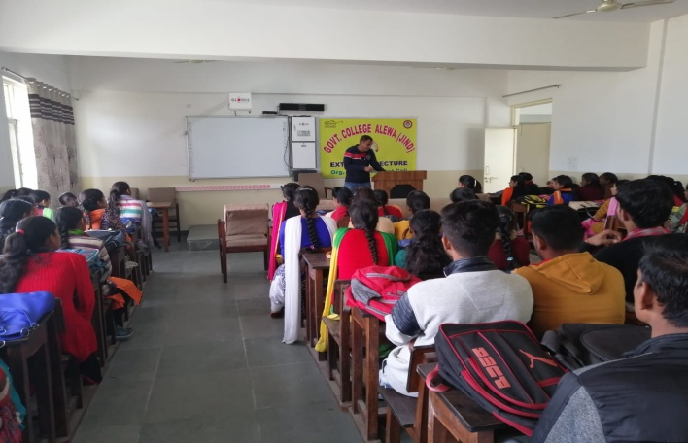

**Day-2: -** On the second day, Mr. Bal Mukund Bhola started with goal setting and public speaking, He pointed out about how to set a goal and what the way of speaking in public, in this participant in tested themselves in such a way that participant introduced his / her to next person.

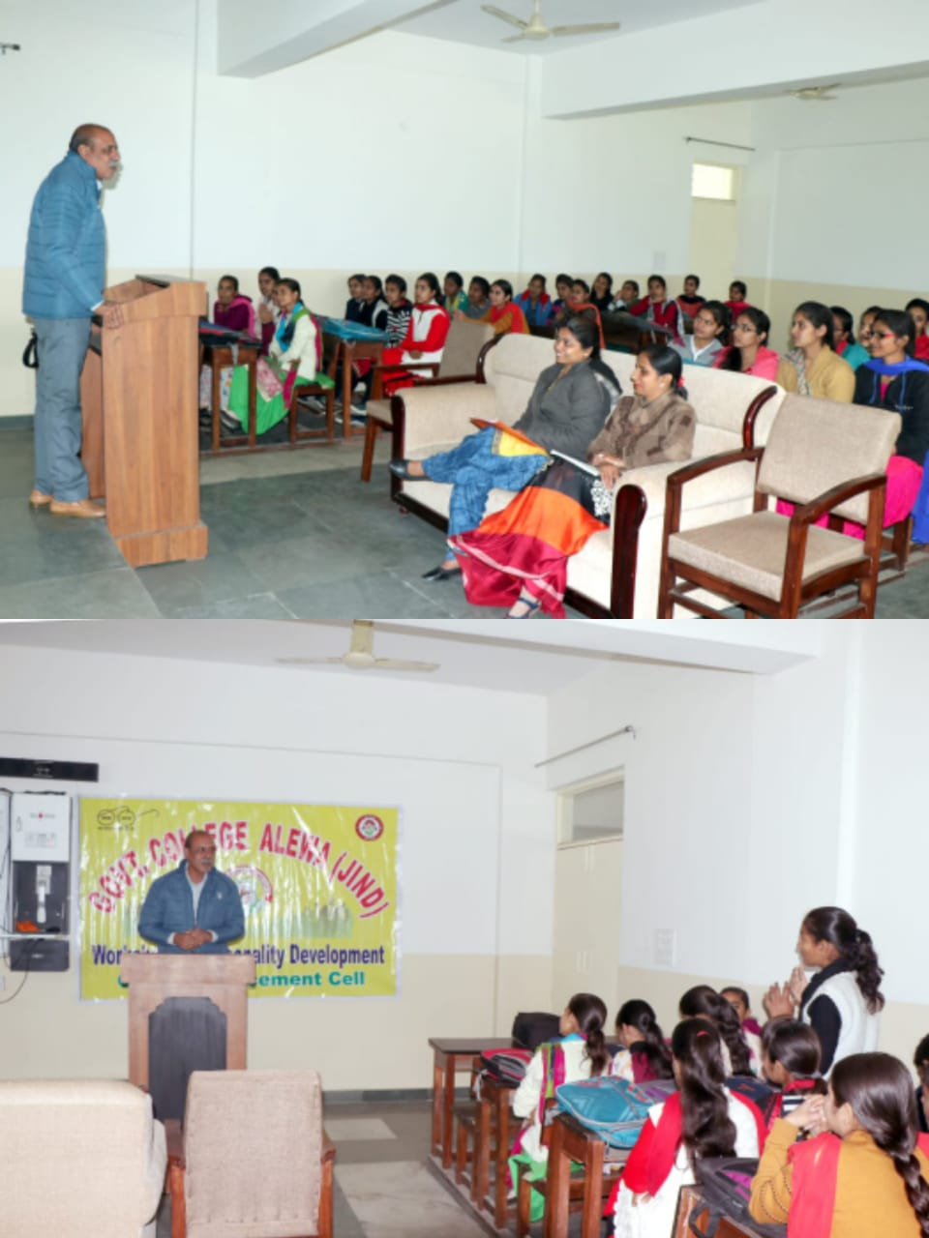 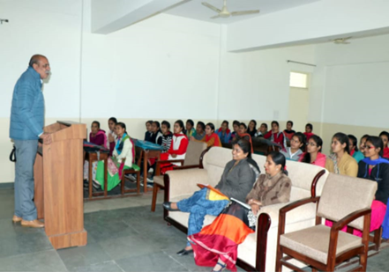

**Day-3:-** On 3rd day, Dr Jaswant Saini delivered lecture on interview scale with PowerPoint Presentation, he pointed out some important question which was only asked during the interview and second lecture was delivered by Doctor Vedpal on communication skill and group discussion, he mentioned that the crucial part of the communication skills listening and attention.

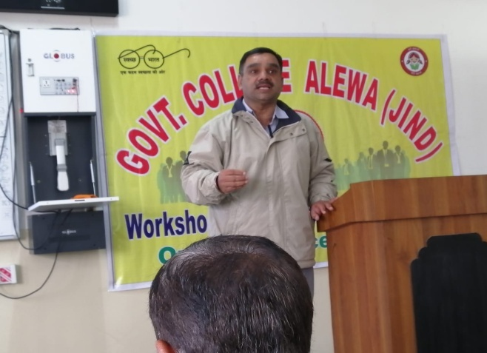

**Day-4: -** On 4th day, Mr. Naresh Jaglan delivered lecture on Stress Management and Career Counseling, he discussed about some strategy like time management planning Execution/ action to overcome the stress.

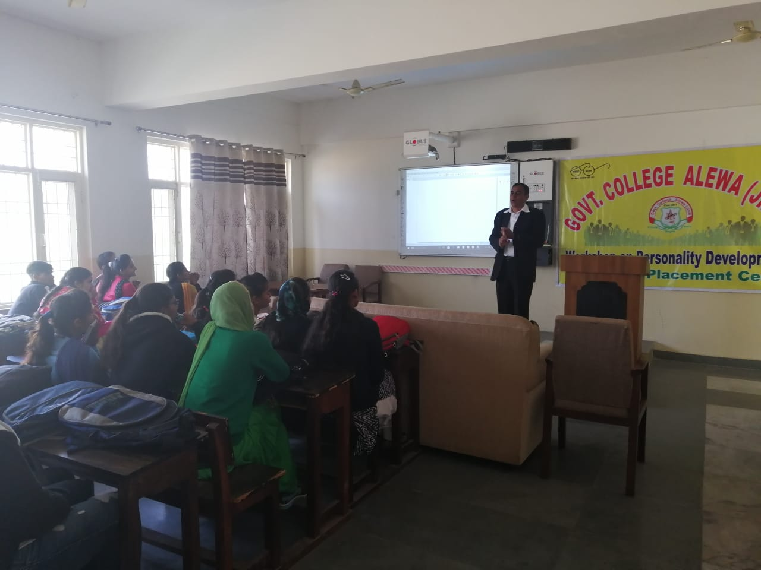

**Day-5: -** On last day Dr. Surender Kumar, Associate Professor discussed about Consumer Welfare E-Business with special reference to competition law in India.

