**Report**

**Lecture on Personality development** **and communication skil**

Two Extension lectures were organised on the topic **personality development** and **communication skills** on 14-10-2019 Dr. Jyoti sheoran Associate professor in the department of English crsu Jind

Delivered the lectures

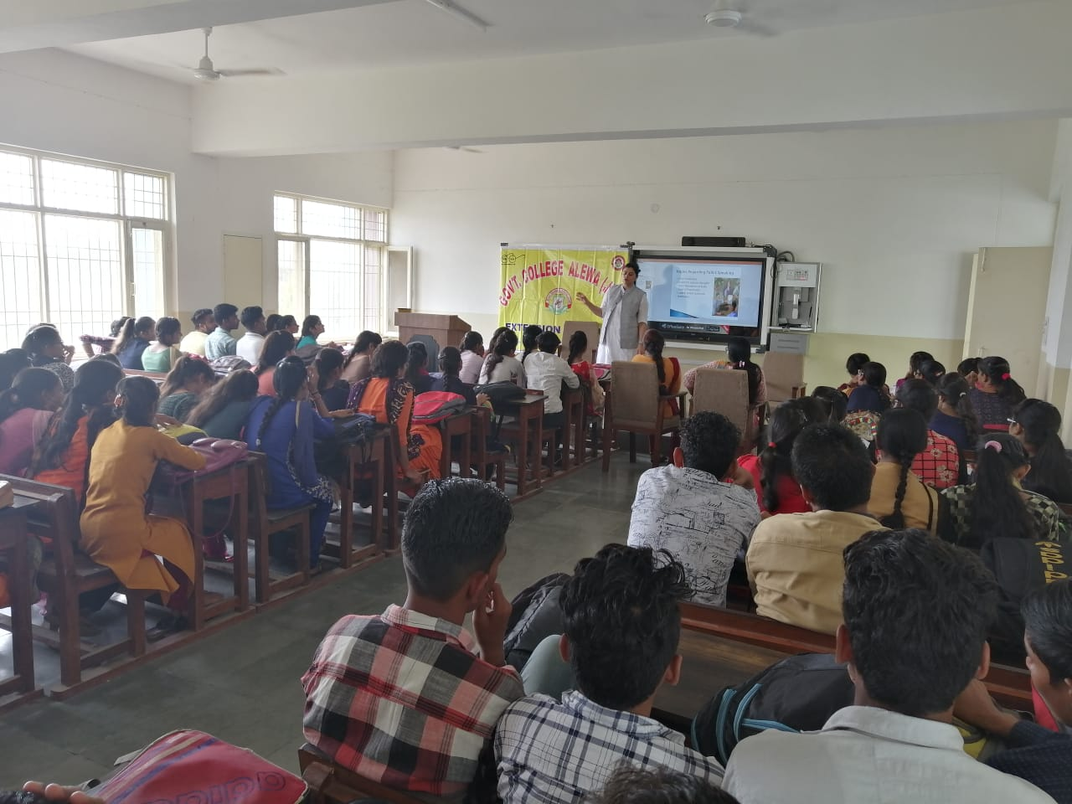

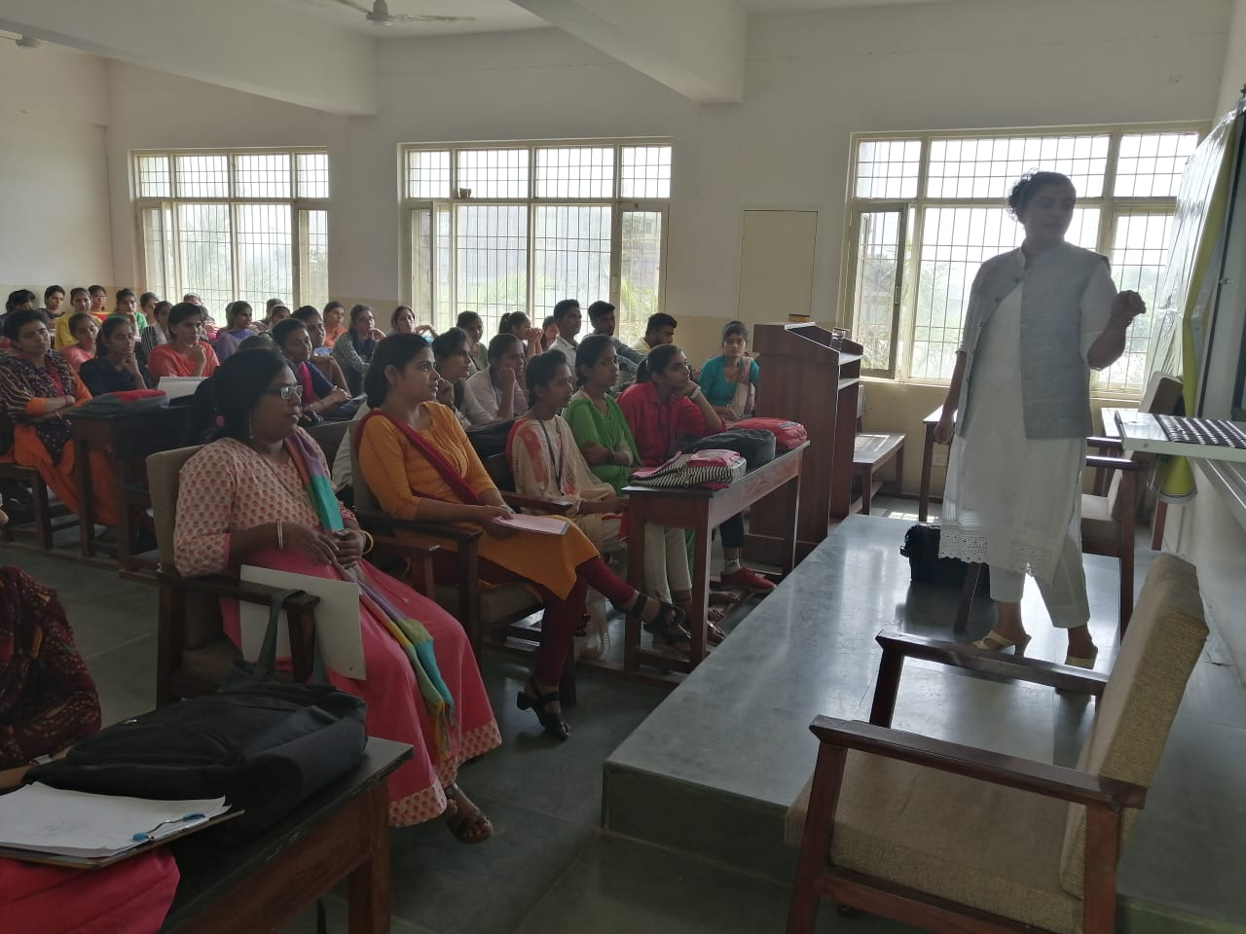

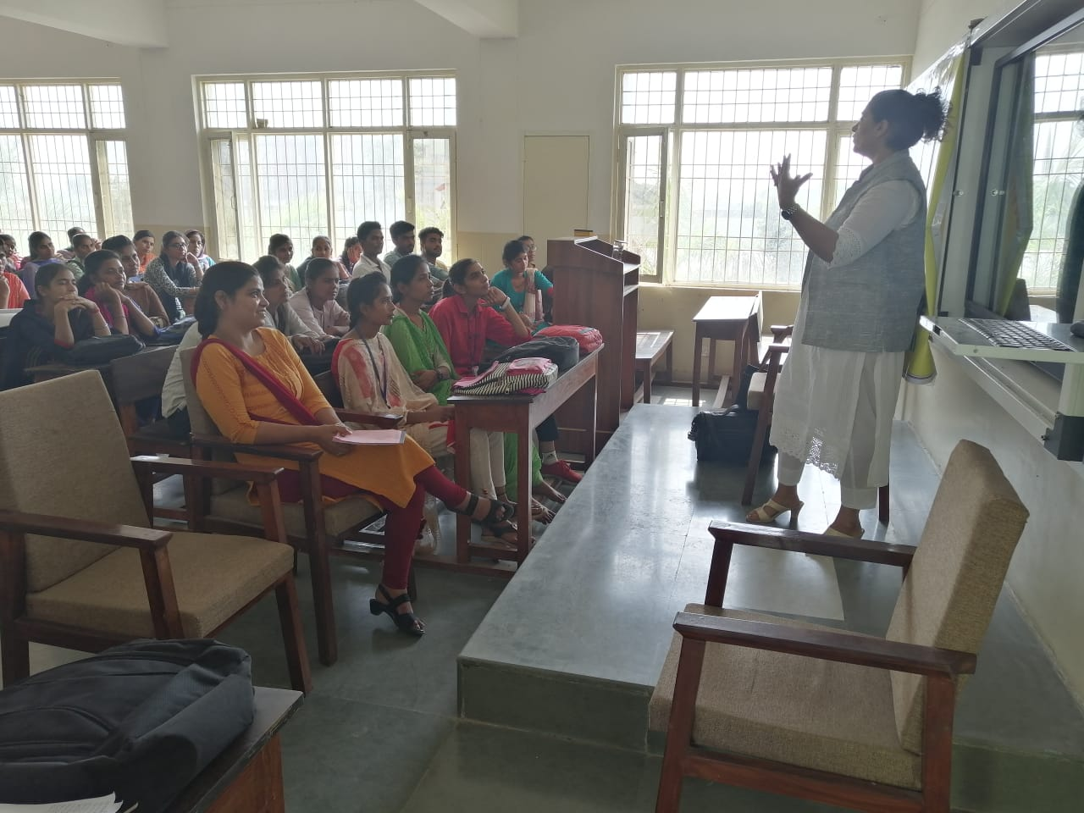

Press note

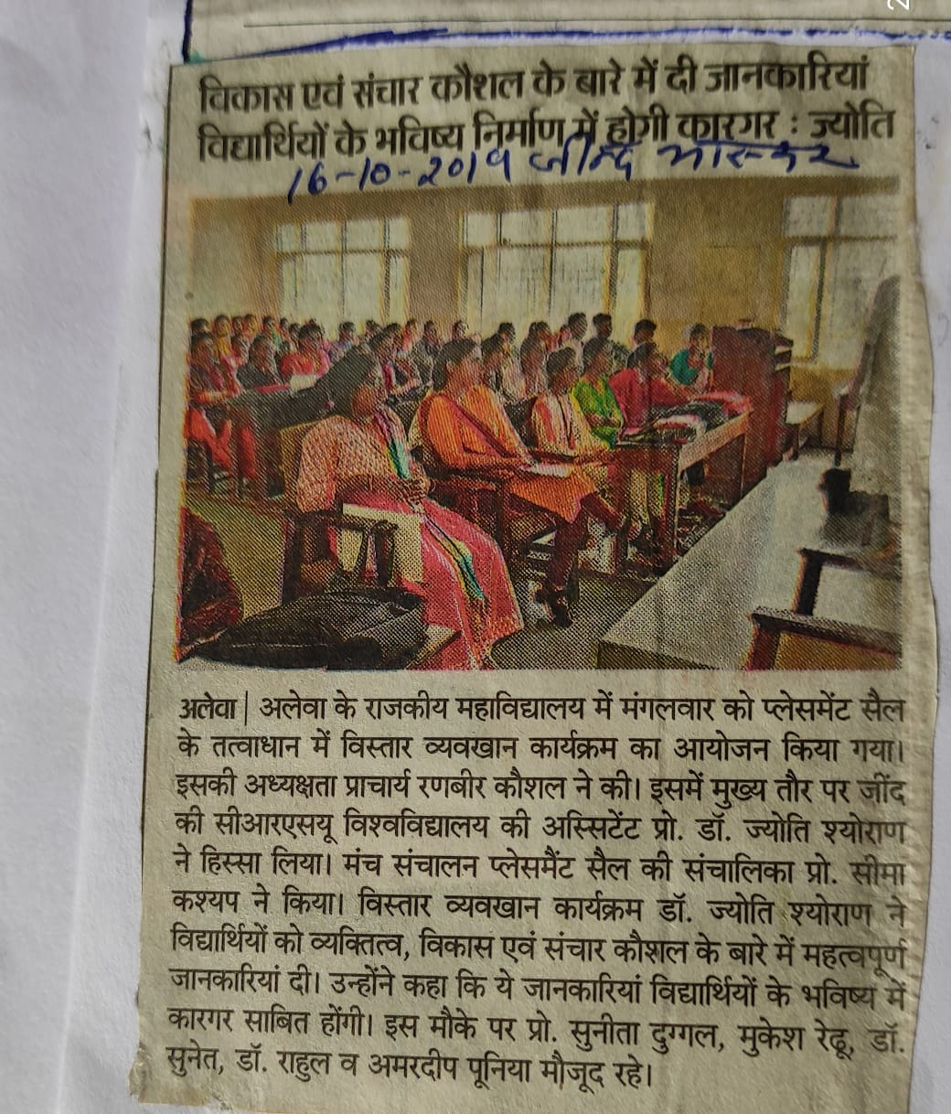

**Report**

**Employability training and placement fair**

Participated in 5 days Divisional level Employalability training and placement fair from 11-15 NOV 2019 Organized by Govt. college hisar under the aegis of D.G.H.E Panchkula. Twelve students got benefited from this job fair. In this, four days they were trained by different by resource person & on the last day they faced interviews in different companies .

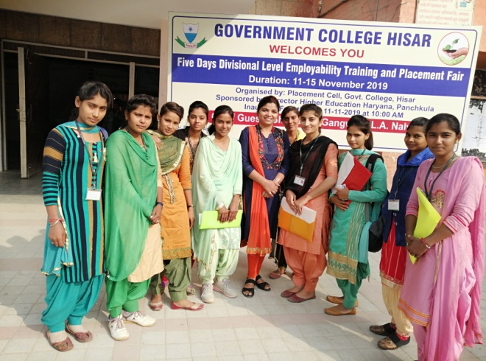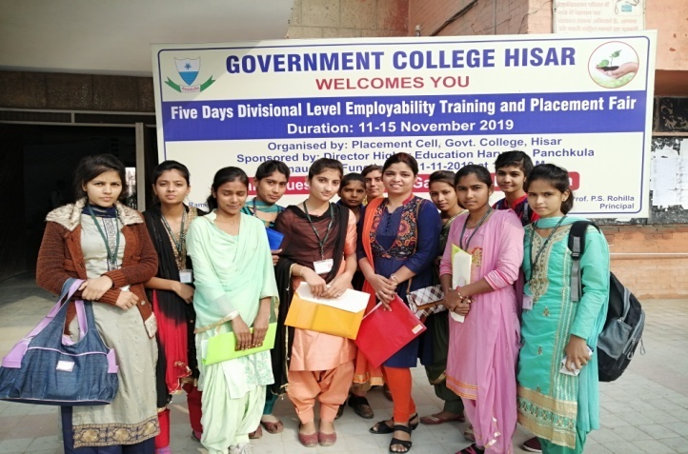

the last session was followed by participants feedback & distribution of certificates by distinguished guests

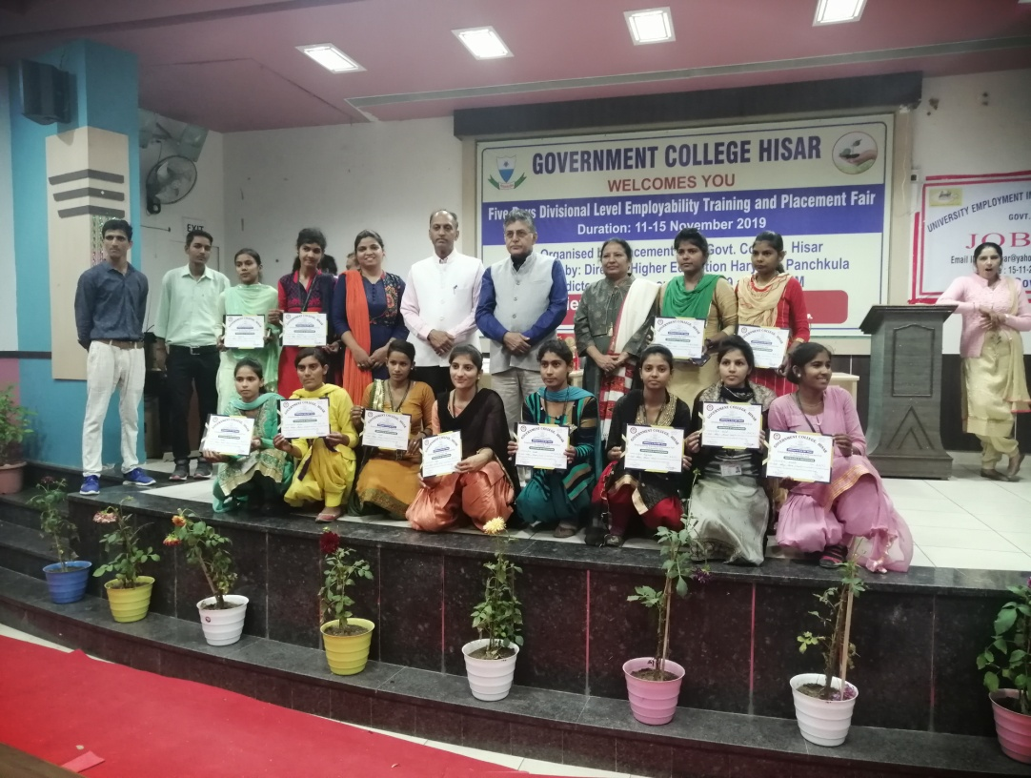

**Report**

**One week Tally Workshop**

One week tally workshop was organised under Placement cell dated 31/01/2020 -09/02/2020. Mr. Sunil kumar Director of Classic computer jind delieverd the lectures with 3 fellow through ppt presentations . He gave the detailed information regarding Tally , Company creation & opening balance ,contra & jouranal vouchers etc via Theoretical & Practical ways .

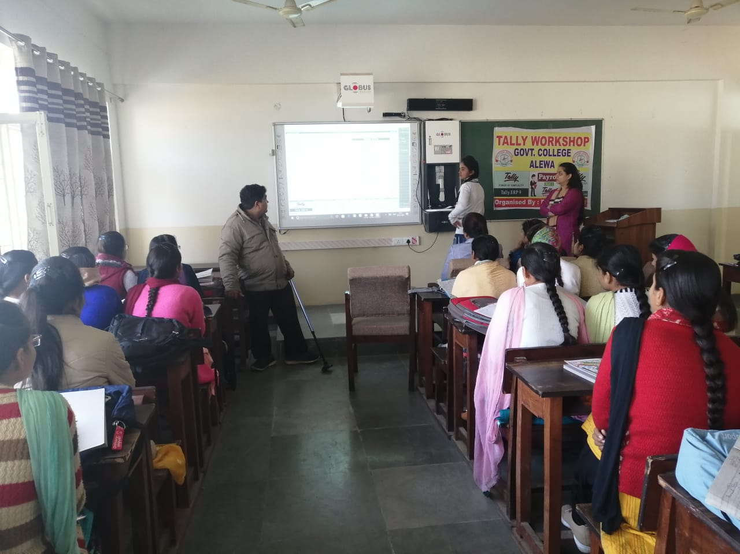

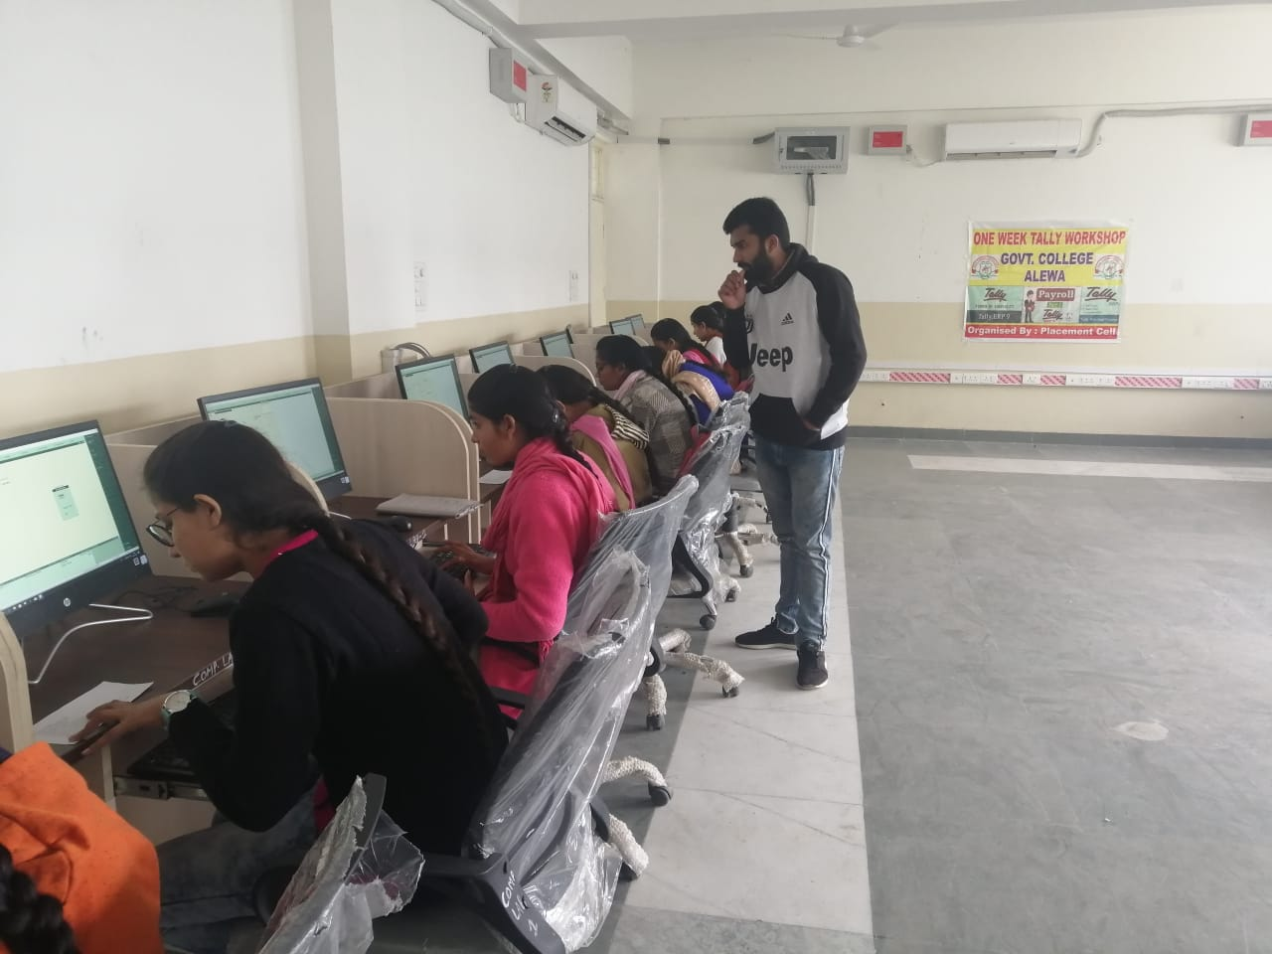

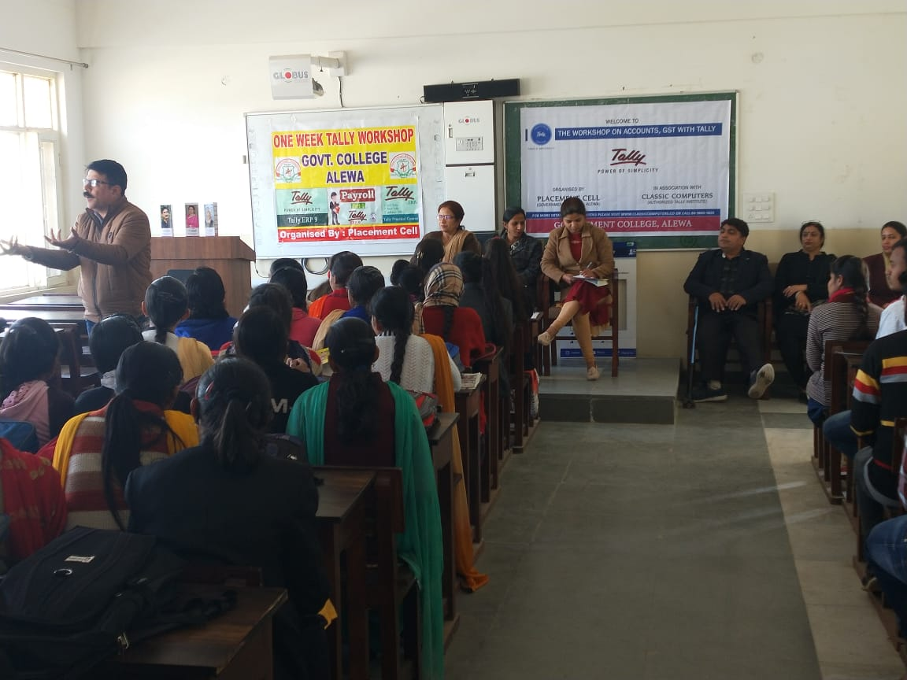

At the end of the workshop, the Certificates were distributed to the participants .

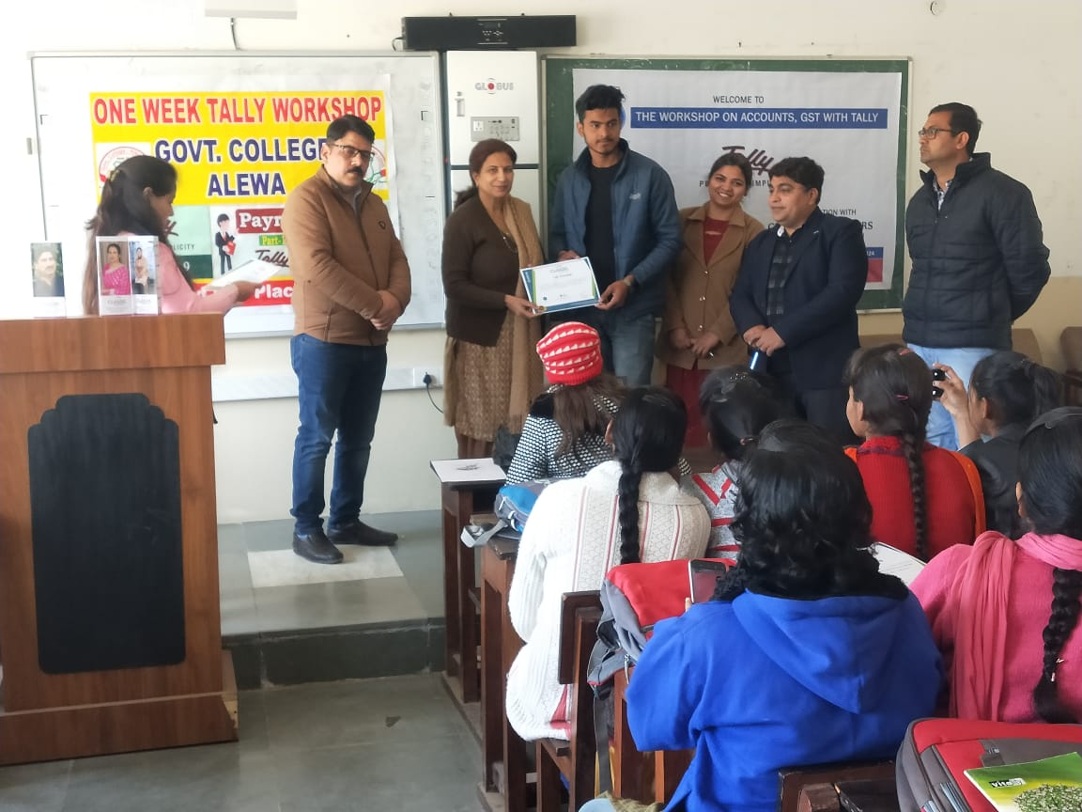

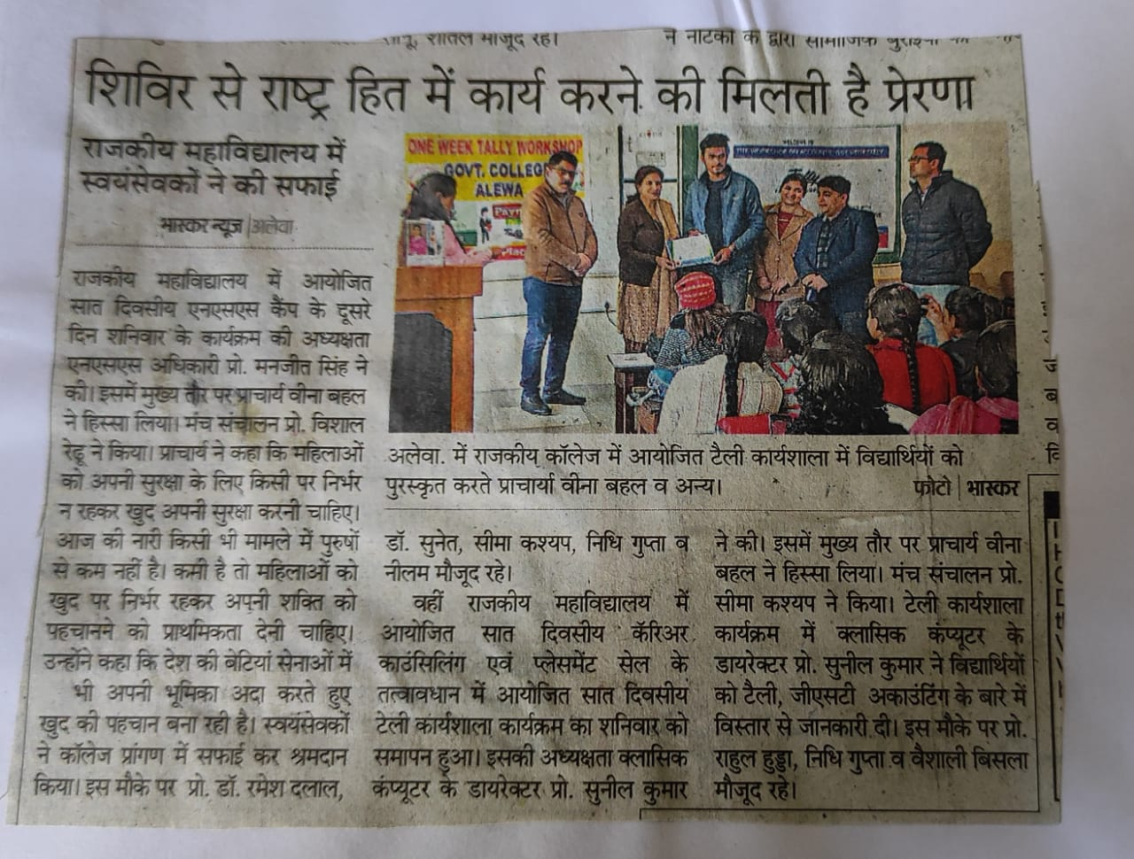

Press note

**Report**

**Lecture on My Next Exam.com portal**

A lectur-cum-workshop was organised on My Next Exam.com Portal on 22/01/2020. in this Assistant Professor Seema Kashyap informed the students about this portal. how to navigate this site, to create an account, and how to reach the various links provided in this portal. At the end of lecture feedback of students were taken

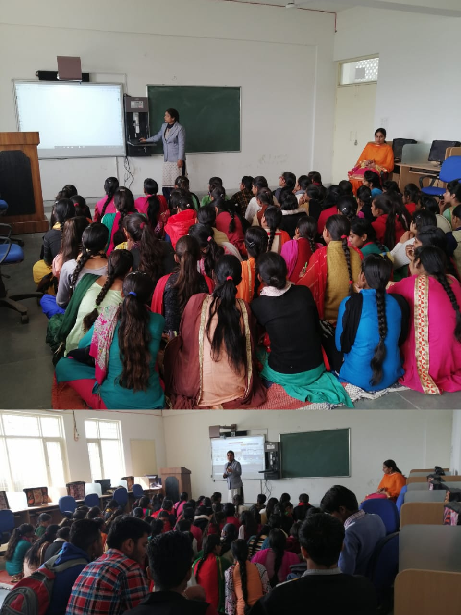

**Report**

**Lecture on personality development and career guidance and development**

Two Extension lectures were organised under placement cell on topic personality development and career guidance and development on 28/02/2020. Mr. Ashu Asst. prof. in Pt. C.L.S. government college Karnal delivered the lecture with PPT