**Report (Session 2020-21)**

**Online Workshop in Chem. Draw App**

1. 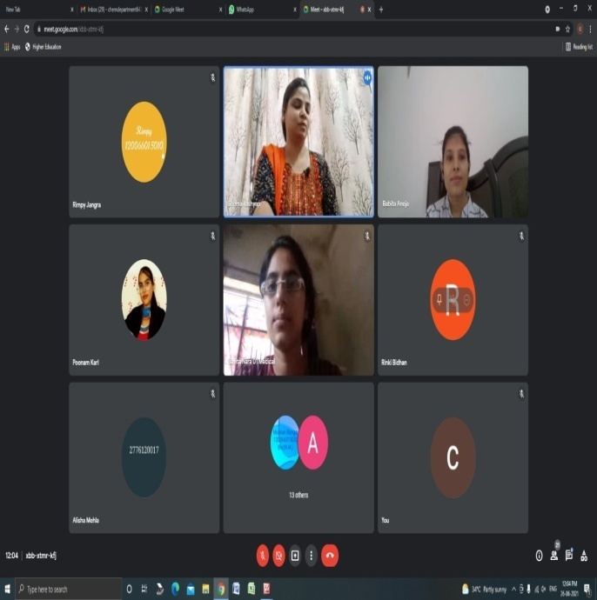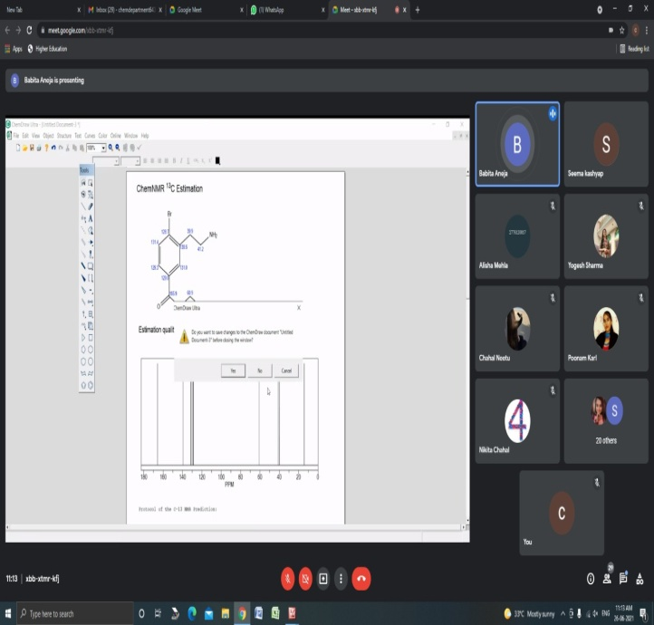One day online workshop was organized on chem. draw app under placement cell in collaboration with chemistry dept. dated: 26/06/2021. Dr. Babita Aneja, Research Scientist in Sphaera Pharma Pvt. ltd. deliverd the lecture. She gave the information about chem draw app, With the help of this app, How they can effectively draw molecules & reactions for use in documents & Electrnic Lab notebooks & to generate accurate name from Structure. Total 35 students participated in this workshop. Mrs. Veena Bahl, Principal of college presided over the programme & motivate the students to participate in such a kind of workshop for enhancing their knowledge. During this workshop placement cell incharge Miss Seema Kashyap, Dr. Manjeet Singh, Mrs. Vaishali Hooda were also present.

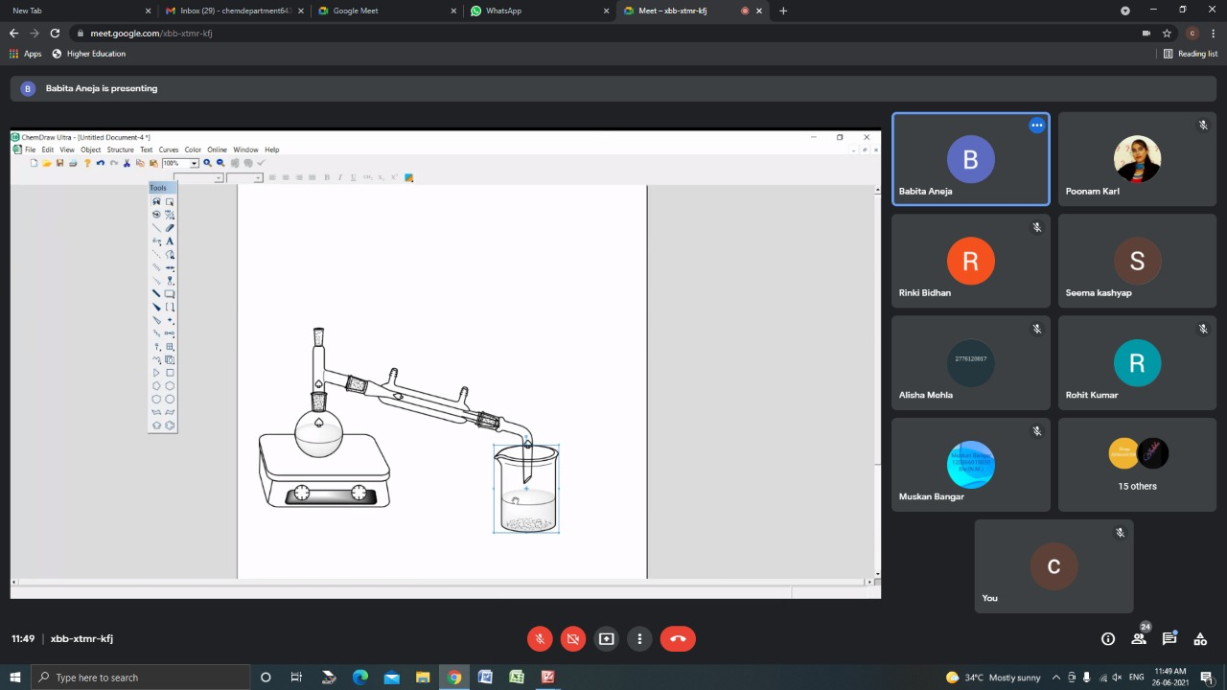

**Web Designing Certification Course.**

1. 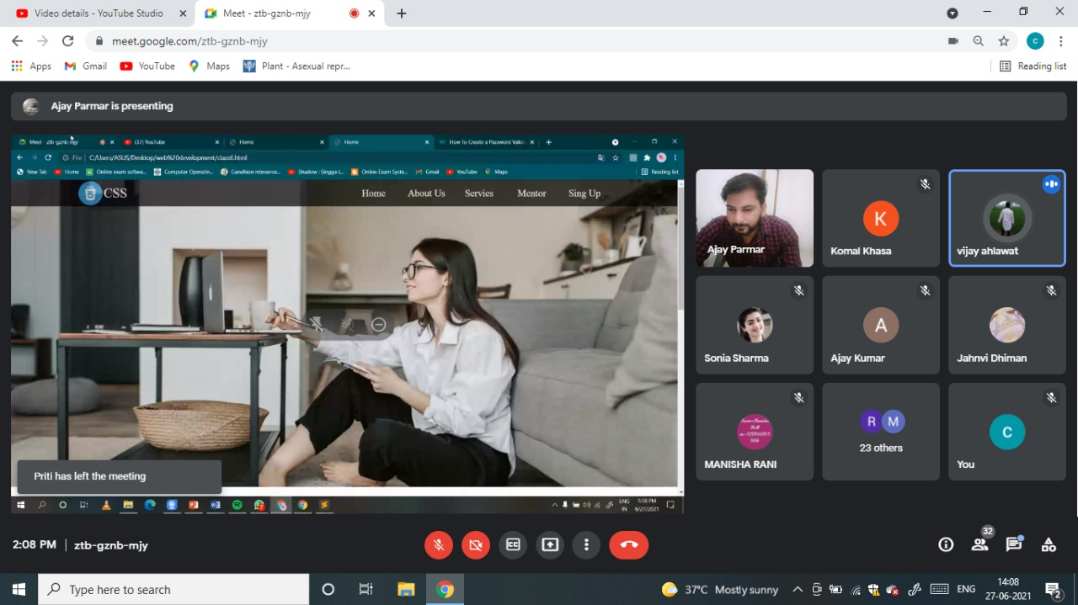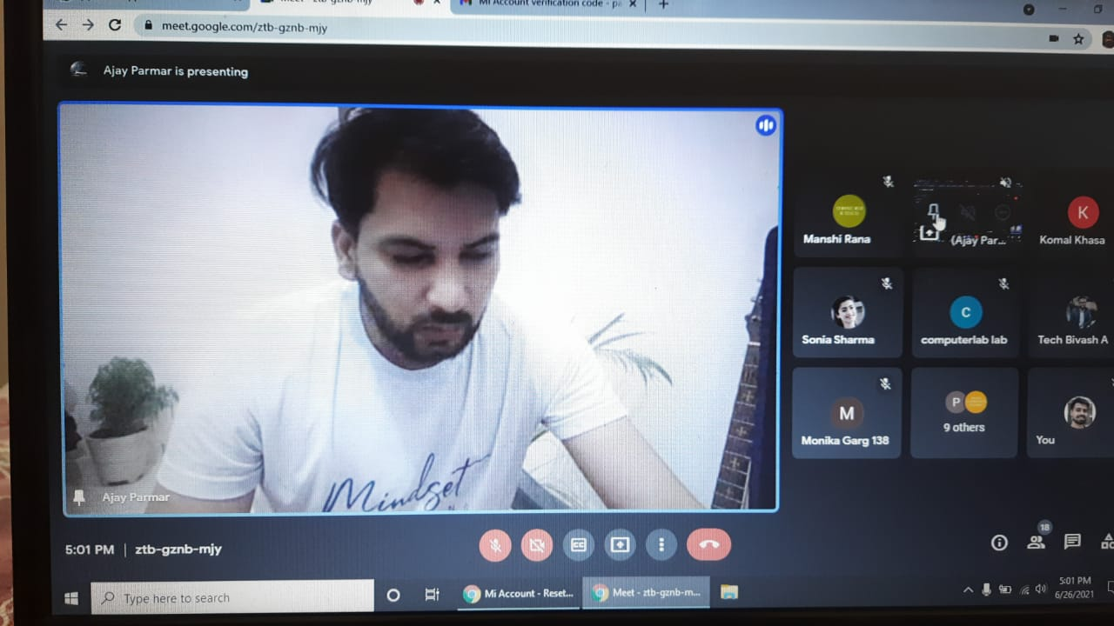 7 days online workshop was organized on web designing under placement cell in collaboration with Jaya I.T Solution Pvt. Ltd Jaipur from 21-06-2021 to 27-06-2021. Mr. Ajay kumar, Web developer in Jaya I.T Solution Pvt. Ltd delivered the lectures. He gave the information about video, Audio, Mutimedia test, post attachment with video & Web- Designing etc. At the last Day of Workshop, Mr. Vijay Ahlawat , Software developer in Bentek Automation Pvt. Ltd. tells the students How they can find job-opportunities in I.T sector if they are from different courses. Total 55 students participated in this workshop. Mrs. Veena Bahl, Principal of college motivates the students to participate in workshops for their overall development & career . During this workshop , Placment Cell Incharge Seema Kashyap, Dr. Sonu, Mrs Vaishali Hooda & others staff members were also present.

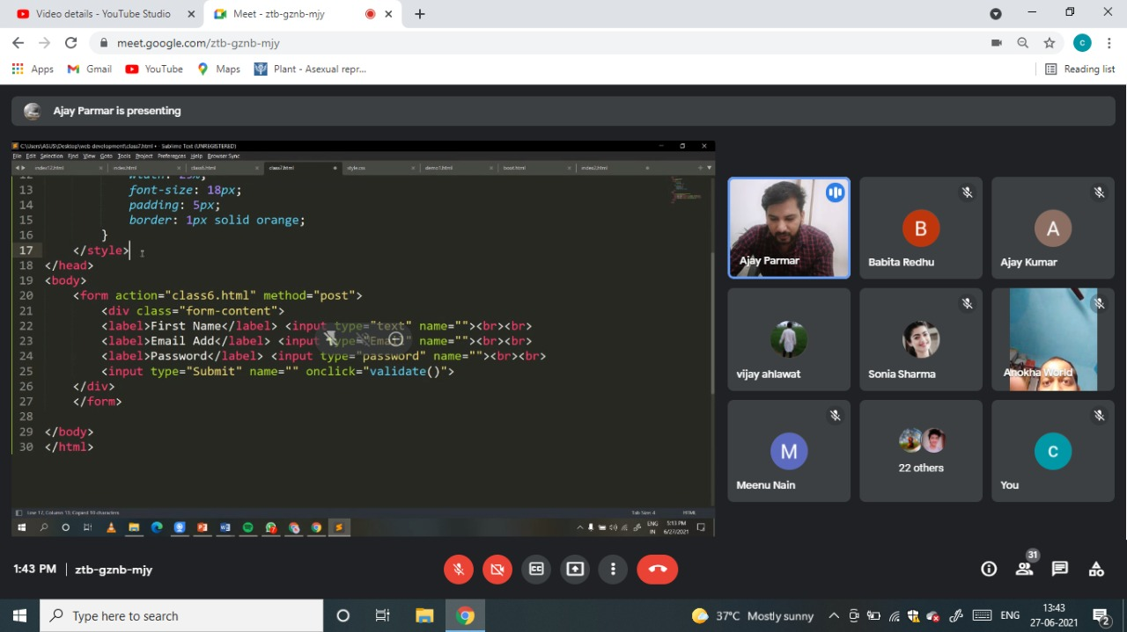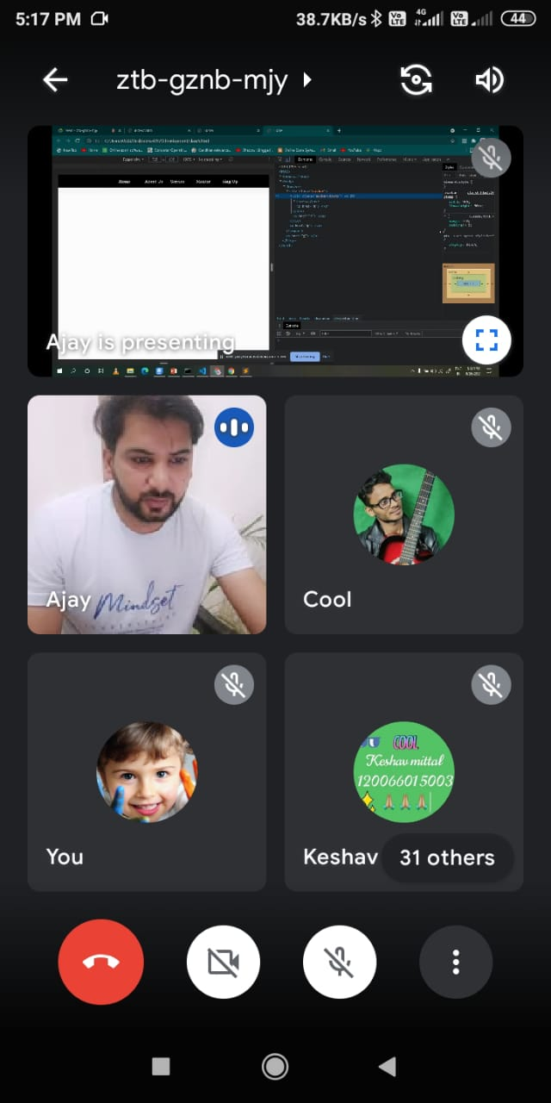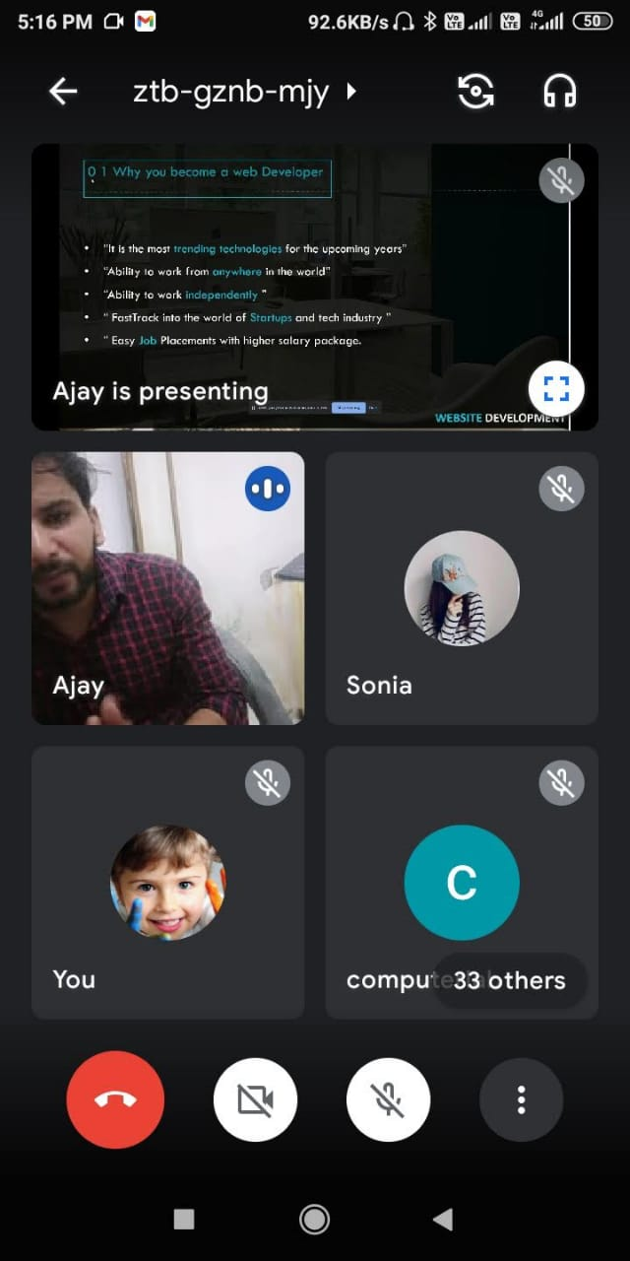

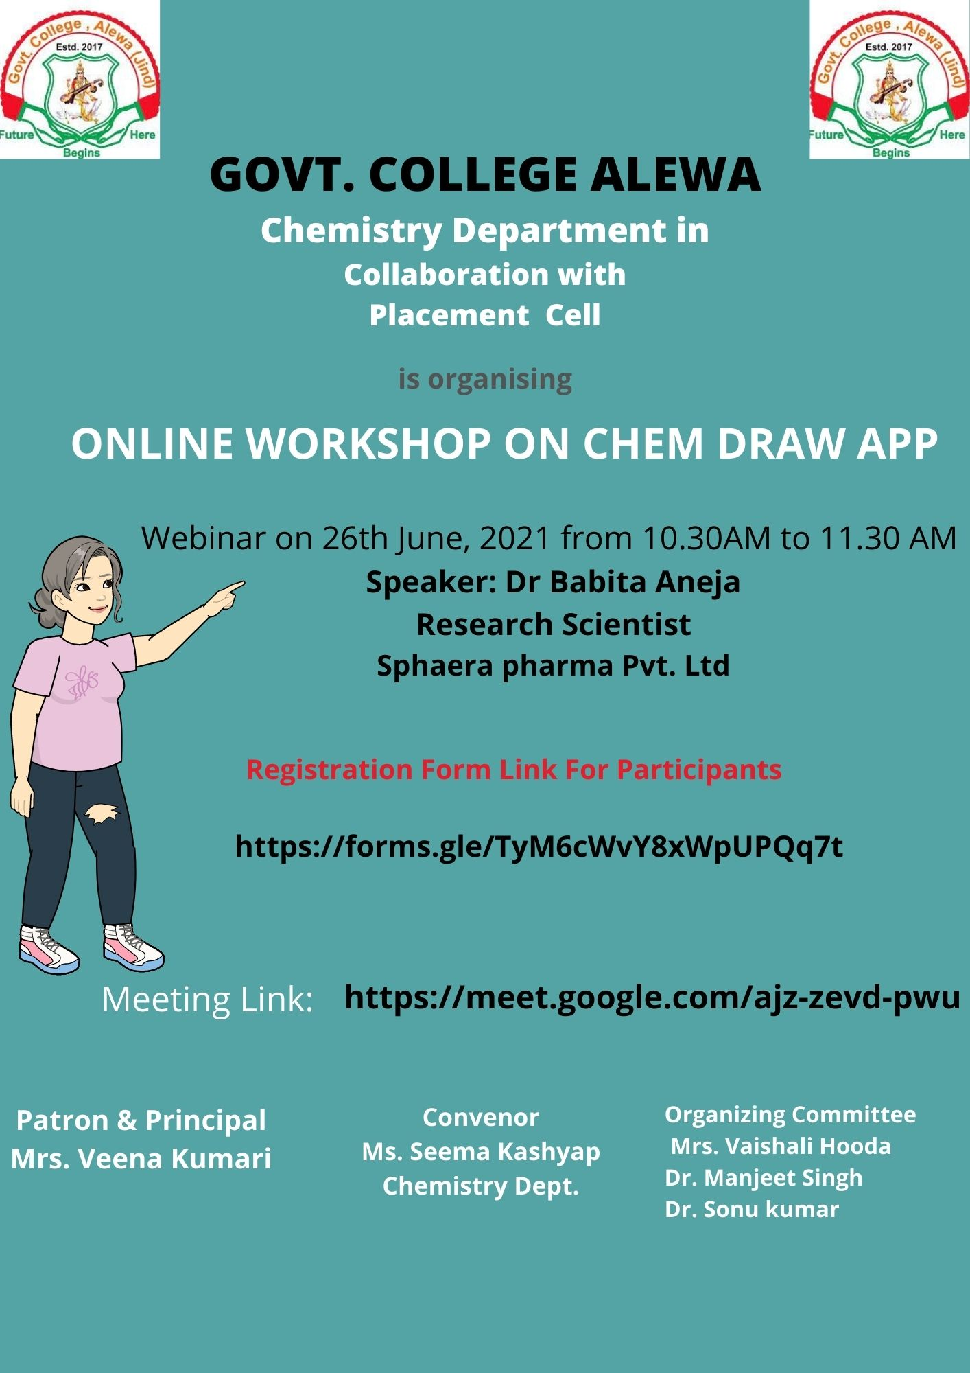

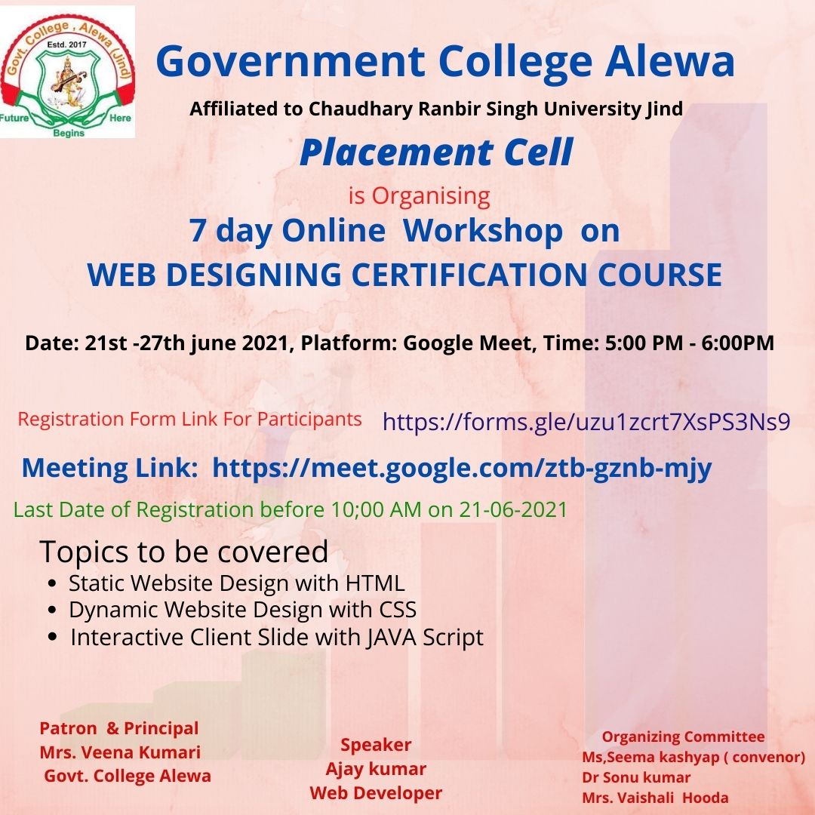

**Certificate**

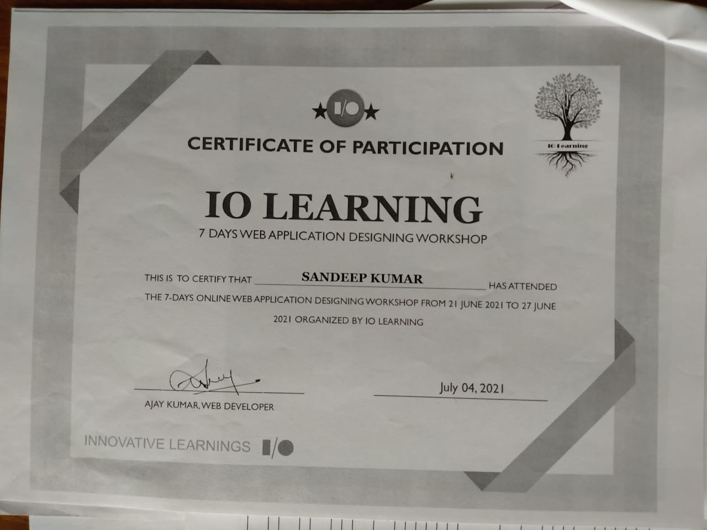

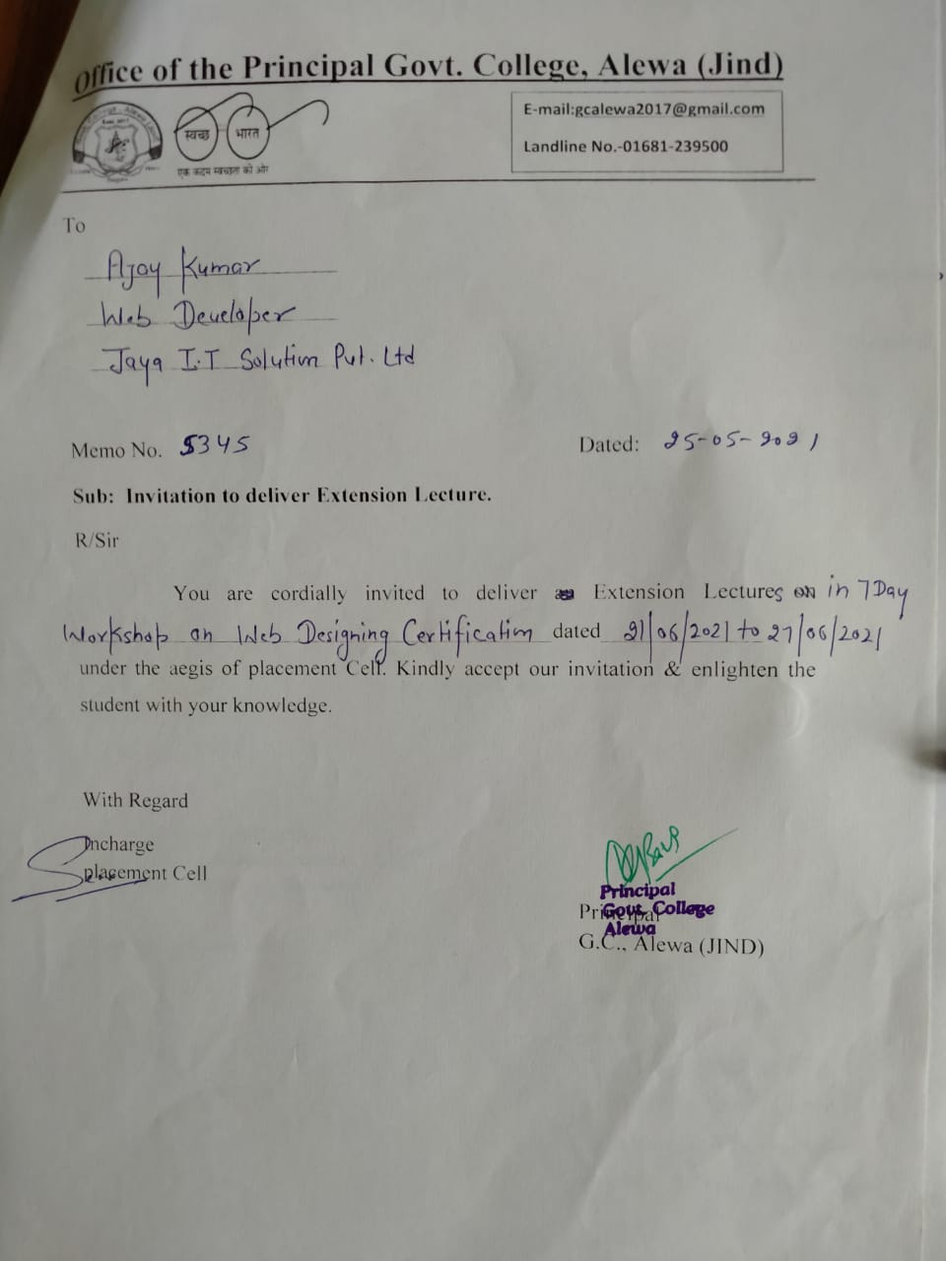

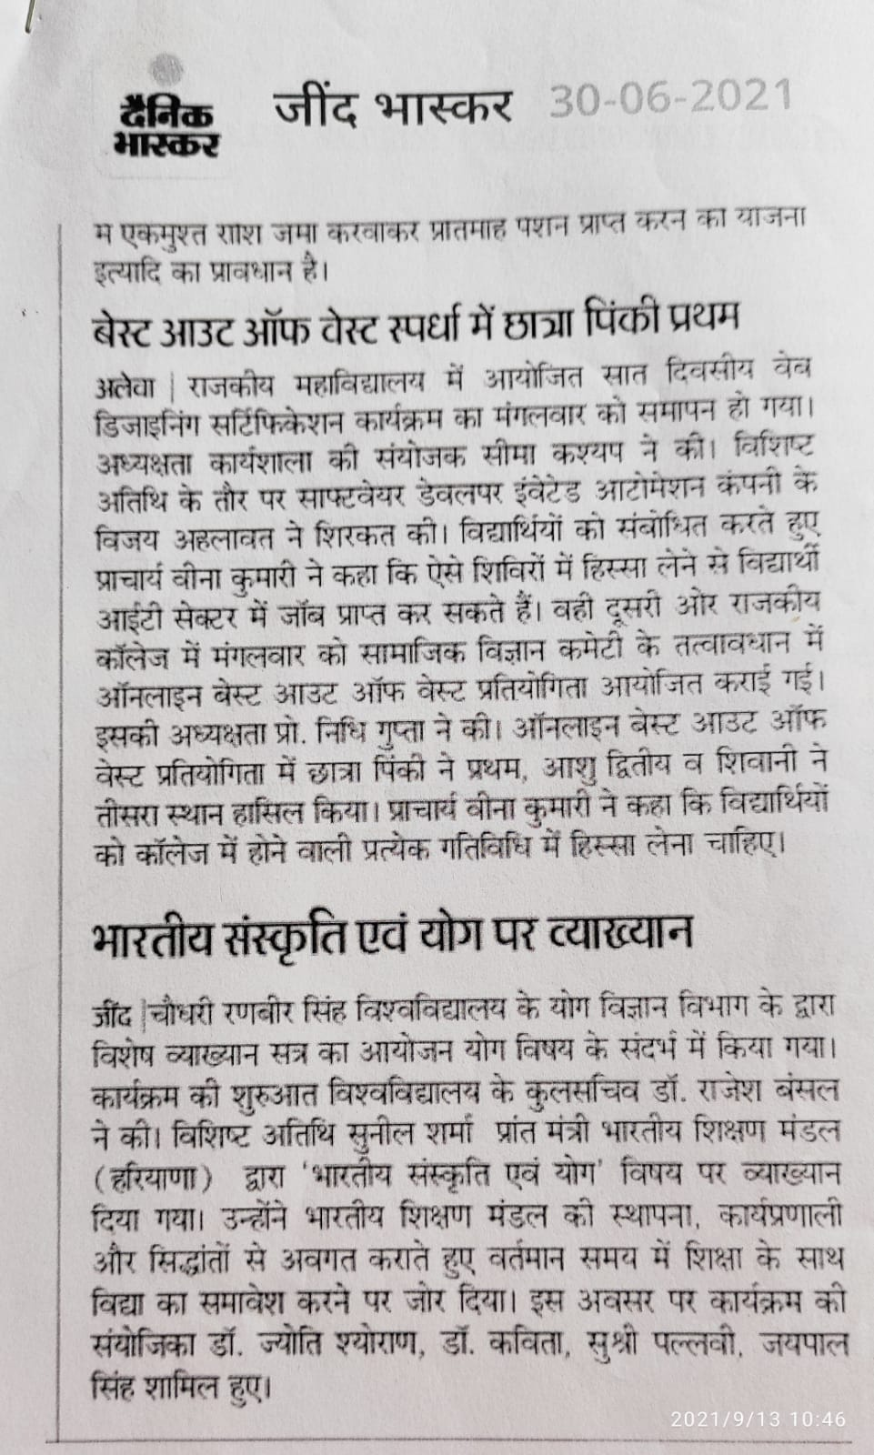 Press Note