**5 Days Online Workshop**

**Interview Skills**

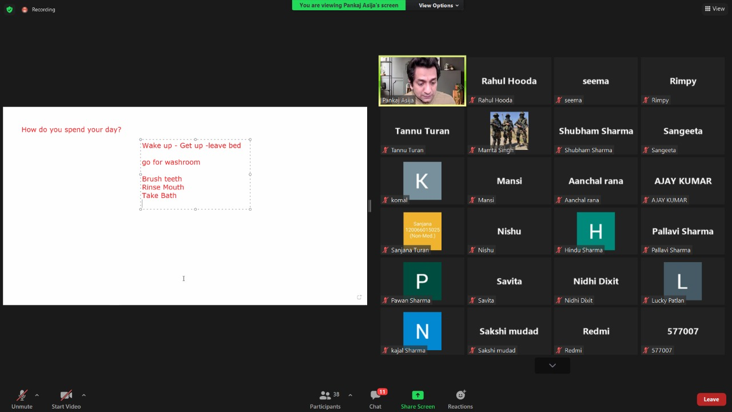5 Days Online Workshop was organized on Interview skills under Placement Cell dated 11 Jan-15 Jan 2022. Mr. Pankaj Asija, Professional Speaker & Coach, Director of PSEL, Hisar, delivered the lectures. He gve the information about what exactly should we do to stand out among the crowed before the placement. He discussed that different jobs require different skills Traits, So we have to be flexible & mould ourself to meet the requirement. The students were very keen for this workshop. Total 45 students participated in this workshop. Mrs. Veena Bahl, Principal of college presided ouer the workshop. & motivate the students to participate in such kind of workshop. During this workshop, Dr. Sandeep Sharma, Prof. Vaishali Hooda, & Dr. Sonu were also present.

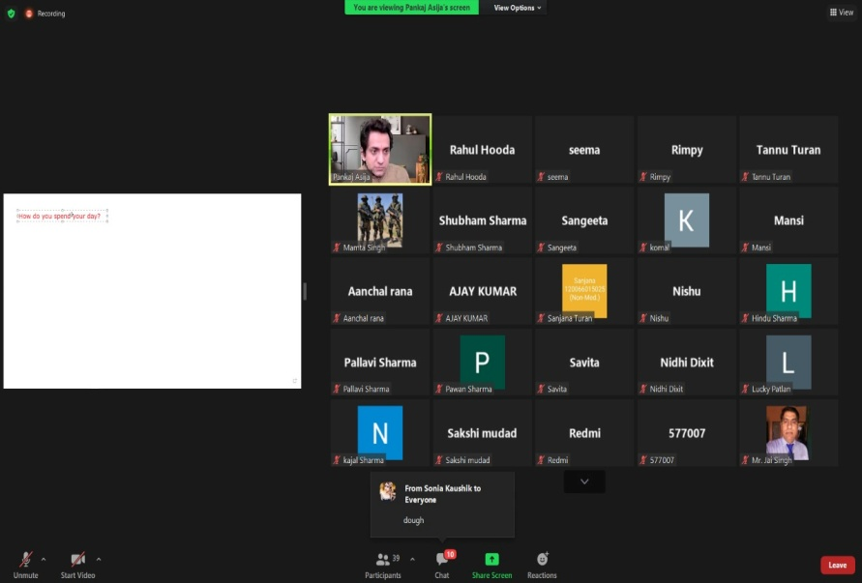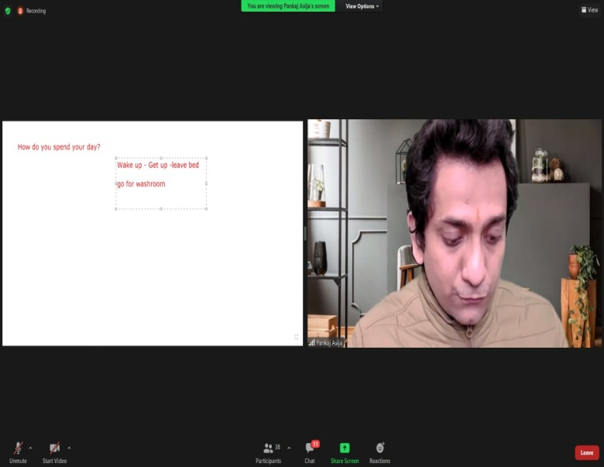

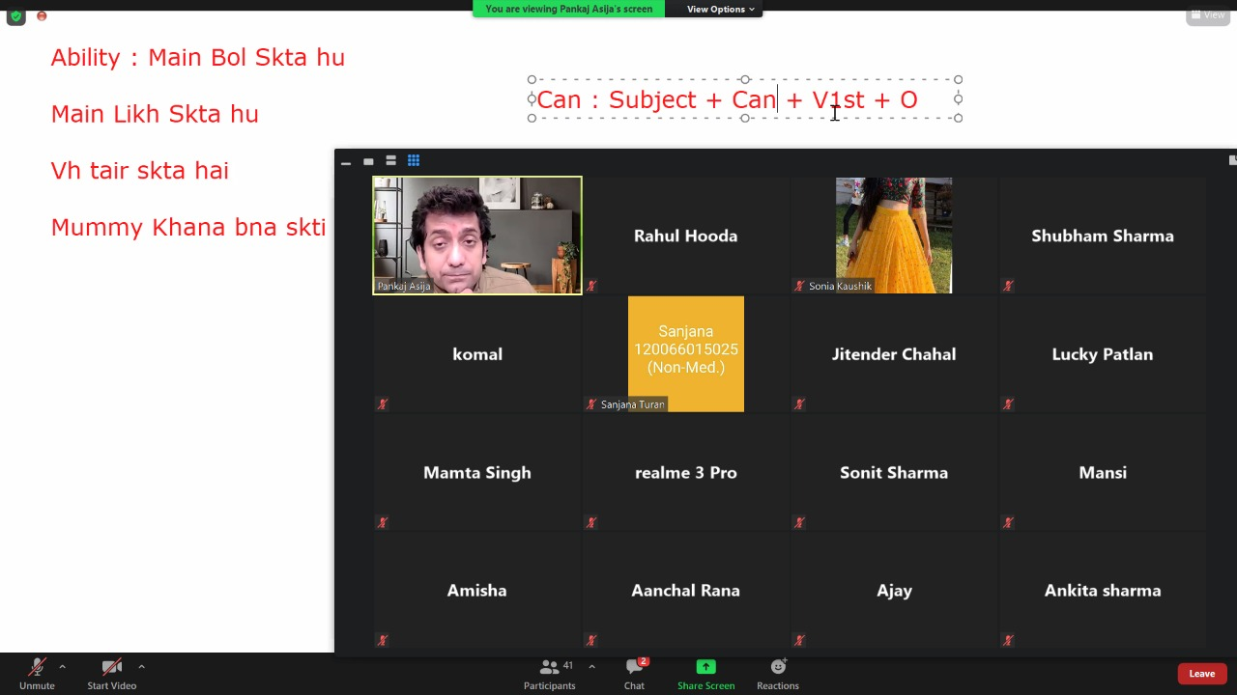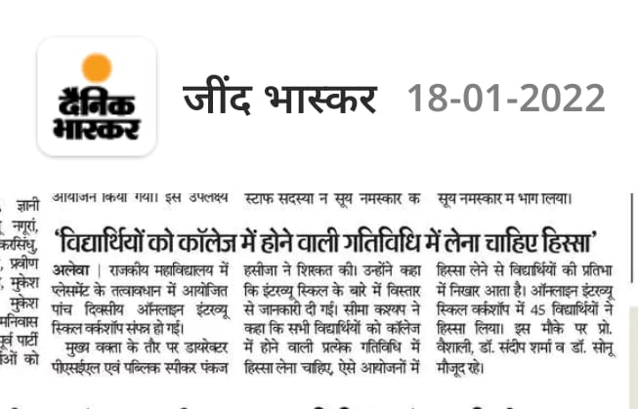

**Extension lectures**

* **Career opportunities for Commerce Students**
* **Soft Skill Requirement for present Market Scenario**

Two Extension lectures were organized on Topics Career opportunities for commerce students, & Soft skill Requirement for present Market Scenario dated 07/02/2022 under Placement Cell. Mrs. Pankaj Batra, Assistant Prof. in Govt. P.G. College Jind delivered the lectures. He discussed about the career. opportunities after graduation in commerce. He discussed about the Job opportunities in banking, Marketing, Insurance Sector. Etc. He also discussed about the Soft Skill Requirement for present Market Scenario. Total 50 students participated in this lecture. During this lecture, Placement cell Incharge-Seema Kashyap, Dr. Neelam, Asst.Prof Vaishali Dr. Sonu & other staff members were also present.

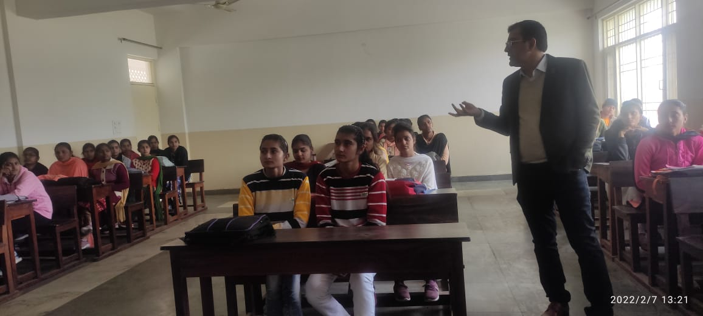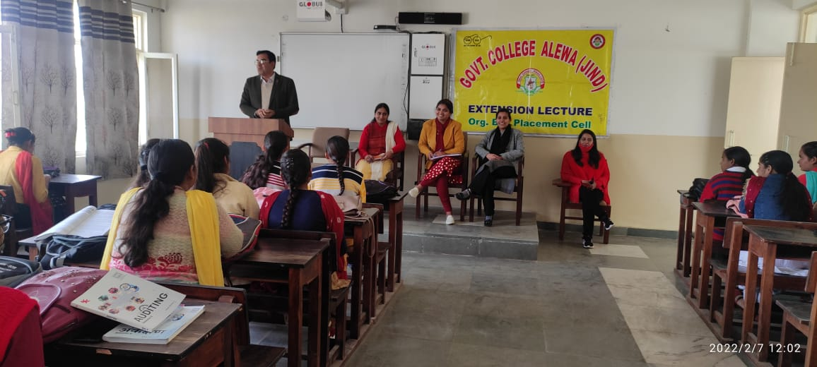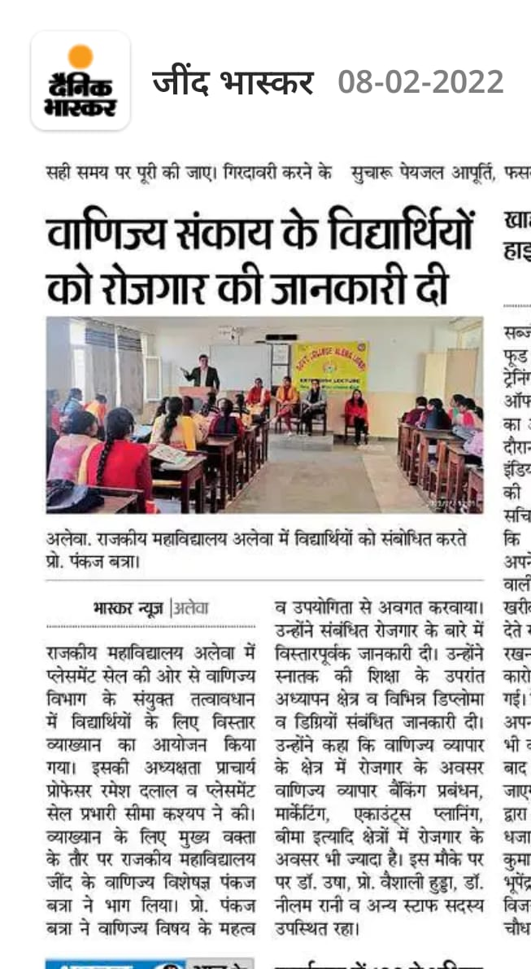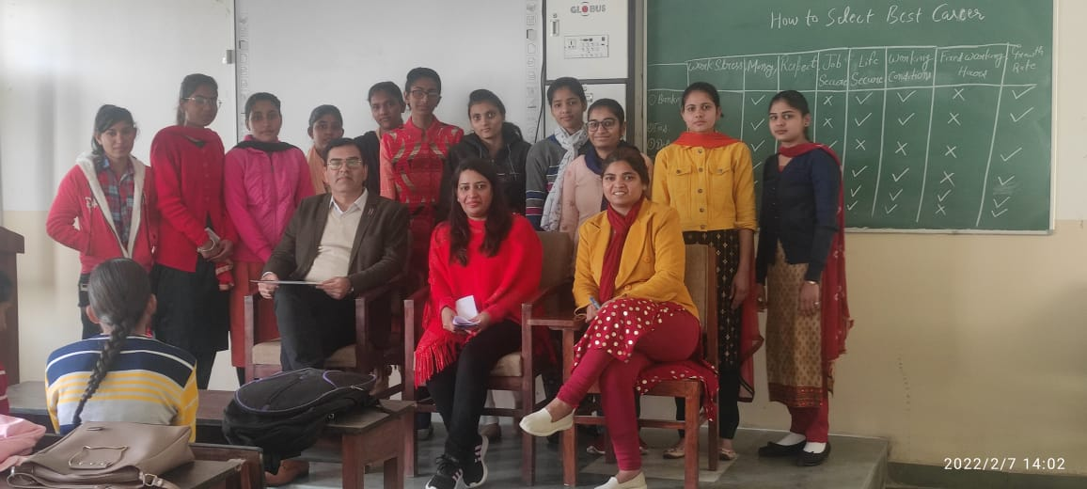

**Extension lectures**

* + - * **Pre- Requisites of Placement**
      * **Role of life Skills in Placement**

Two Extension lectures were organized on topics Pre-Requisites of Placement & Role of life skills in Placement on 08/02/22 under placement cell . Dr. Jyoti Sheoran , Associate Prof. in Department of English C.R.S.U. Jind delivered the lectures . She discussed about the Pre-Requisites before appearing for placement. She says that you should have to develop the interpersonal Skills so that you can influence other effectively you should have the positive energy / Enthusion & drive to take up Challenging task. It was extremely informative seession . The Students show active participation . Total 52 students participated in this lecture . during this lecture Prof. Ramesh dalal, Dr. Sandeep Sharma, Mrs. Vaishali, Ms. Seema Kashyap ( Placement Cell Convenor ) wre also present.

