**Report**

**Extension lecture**

**Topic – How Crack UPSC Exam**

**&**

**How to Face UPSC Interview**

Two Extension lectures were Organized on Topics How to Crack UPSC Exam & How to face UPSC Interviews in Placement Cell dated 06/3/2023 . Mr. Deepak Bhaker, Assistant Prof. in Department of Geography Govt College Julana, Jind delivered the lectures. He Discussed about the pattern & Eligibility of UPSC Exam & give guidance for preparation For Example Starts Reading newspaper regularly, Relevant articles can be identified with the help of Syllabus, After covering Basics from NCERTS go through standard books & cover the syllabus of main Exam of both general Studies & optional Subject with proper Revision. It was Extremely informative Session. The Students Show active participation. Total 49 Students participated in this Lecture. During this lecture, Prof Ramesh Dalal, Ms. Seema Kashyap, Mrs. Soniya, Dr. Usha, & Dr. Amardeep were also present.

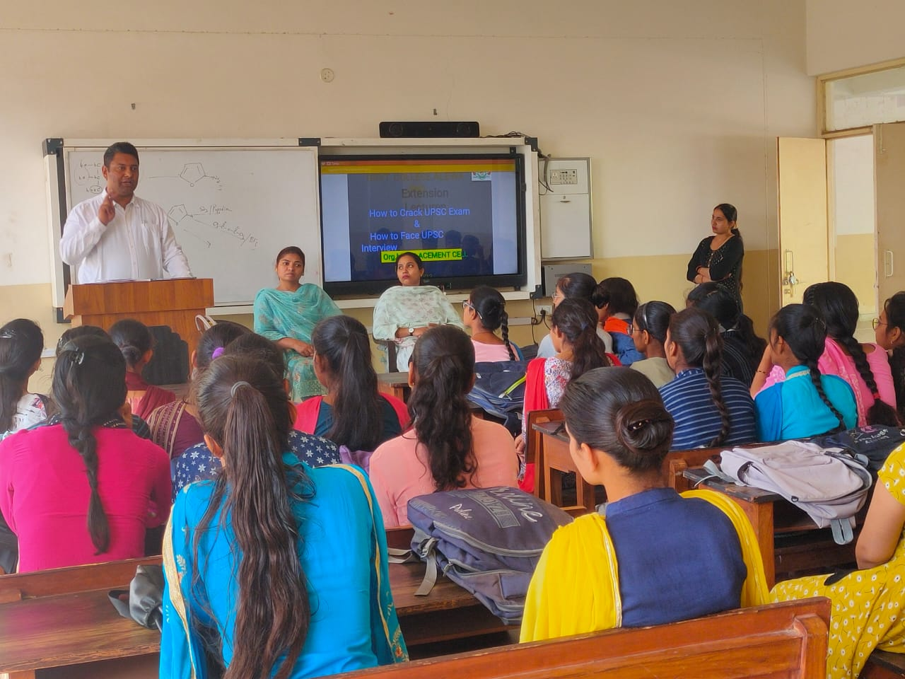

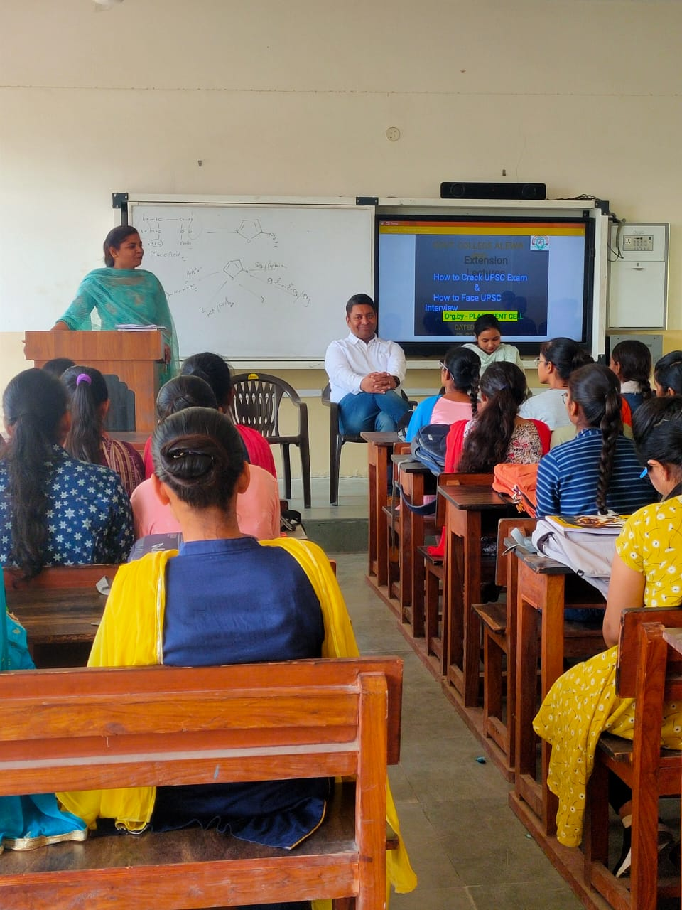

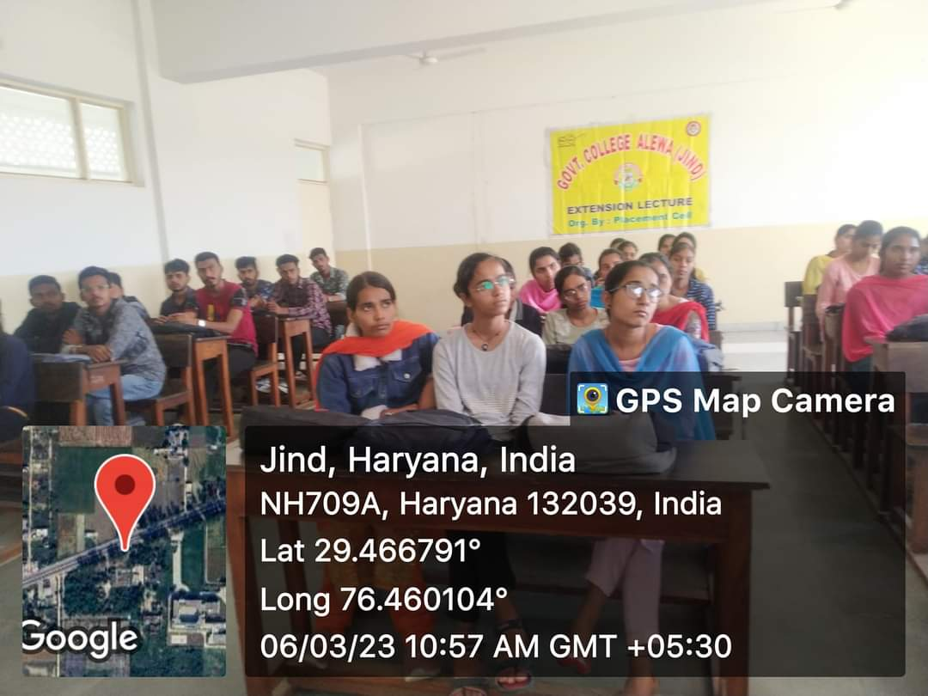

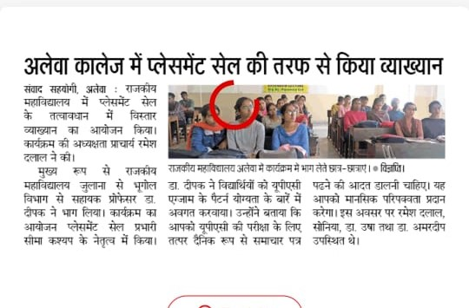

**Report**

**Industrial-cum-Educational Visit**

**( National Dairy Research Institute Karnal )**

An Industrial-cum-Educational visit was organized under the aegis of EDC in Collaboration with Placement Cell & Chemist Dept dated 11/3/2023. 28 Students along with 3 staff member visit National Dairy Research Institute Karnal. we left our College at 8:15 AM, Here Dr Rakesh from Dairy Extension Department NDRI Karnal shows the different department of NDRI Karnal & explained about the Milk processing & processing of Dairy products. He says that Processing of Dairy products give Small Scale Dairy producers High Cash Income than Selling raw milk & offer better opportunities to reach regional & Urban markets. He gave information about the portal Where they can apply for placements in NDRI & also gave information about the workshop & training organised for students & Ladies in processing of dairy products. He also motivated the Students How They can use this Idea as Start up. The Students were very keen for this visit

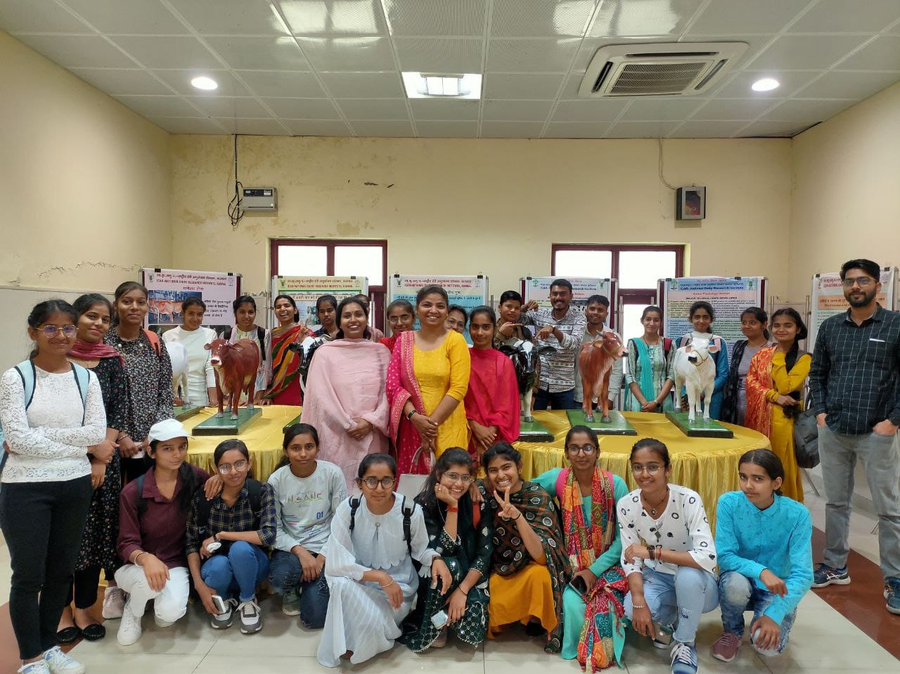

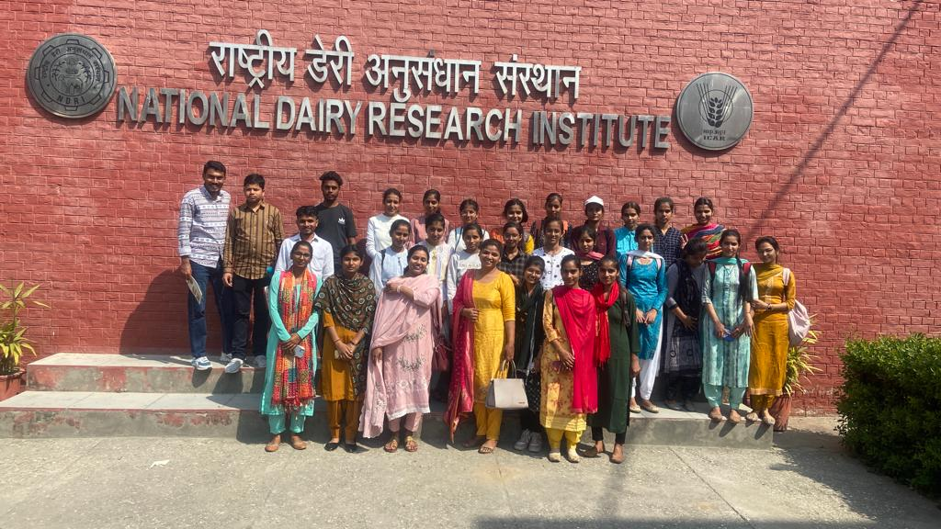 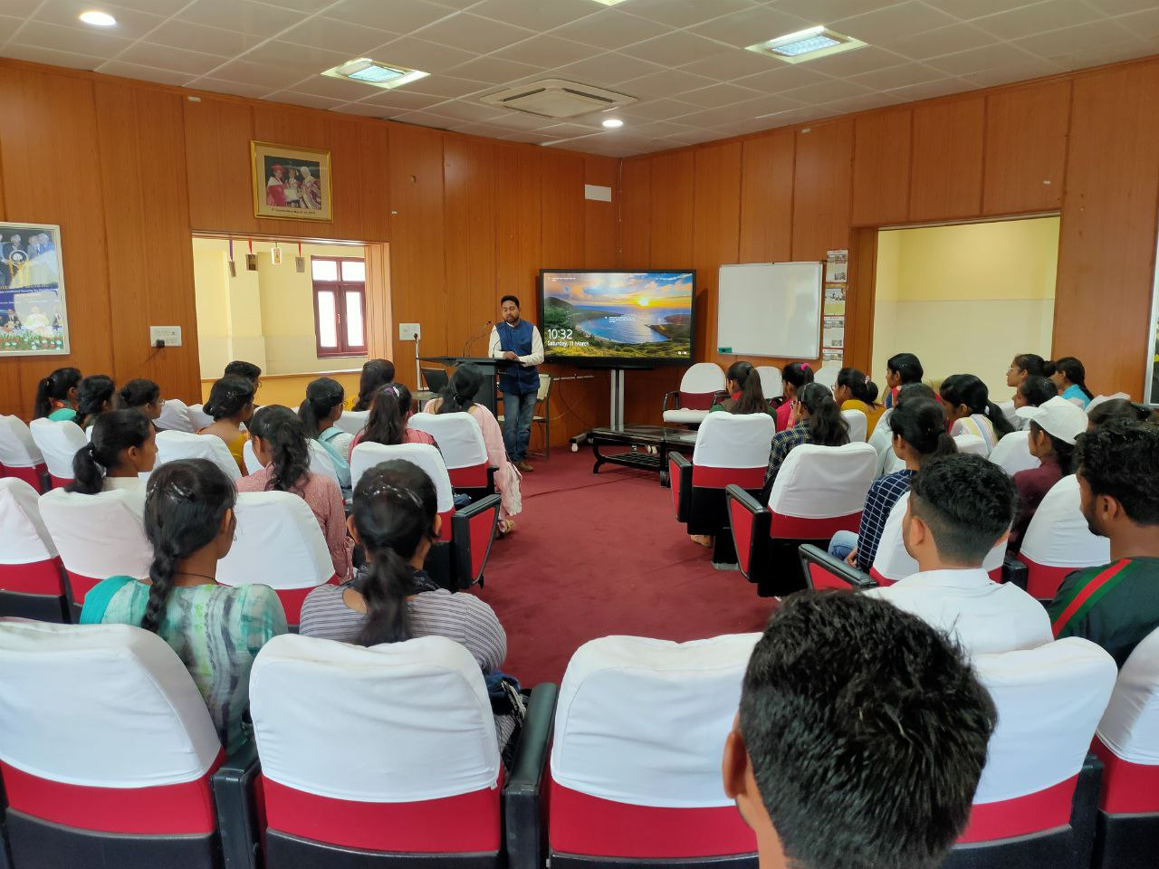 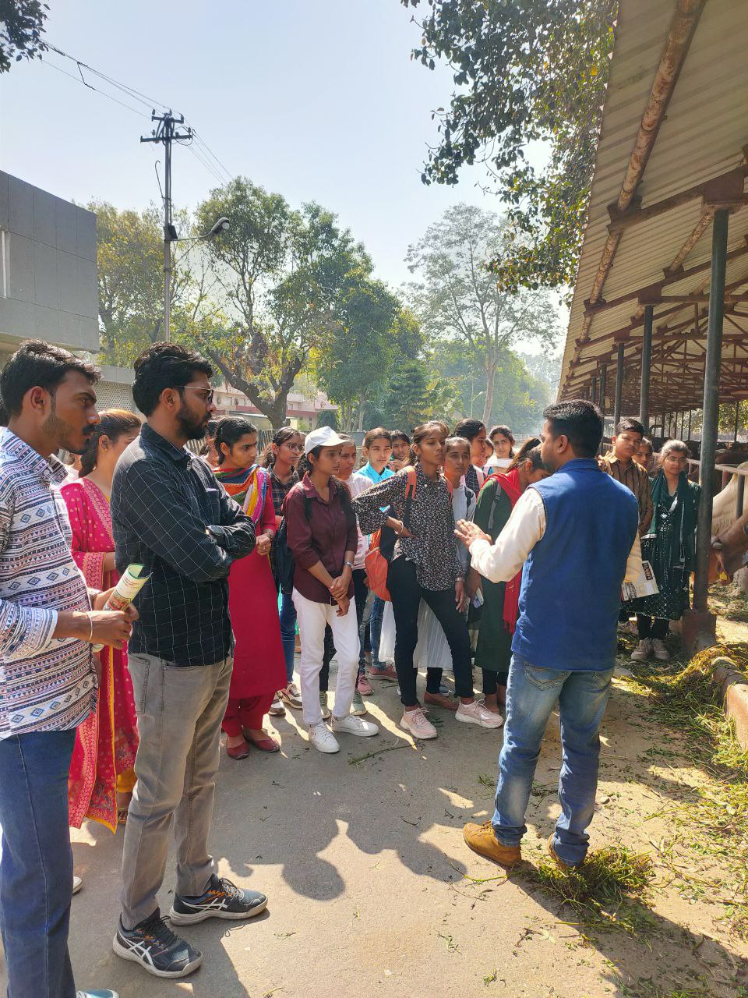 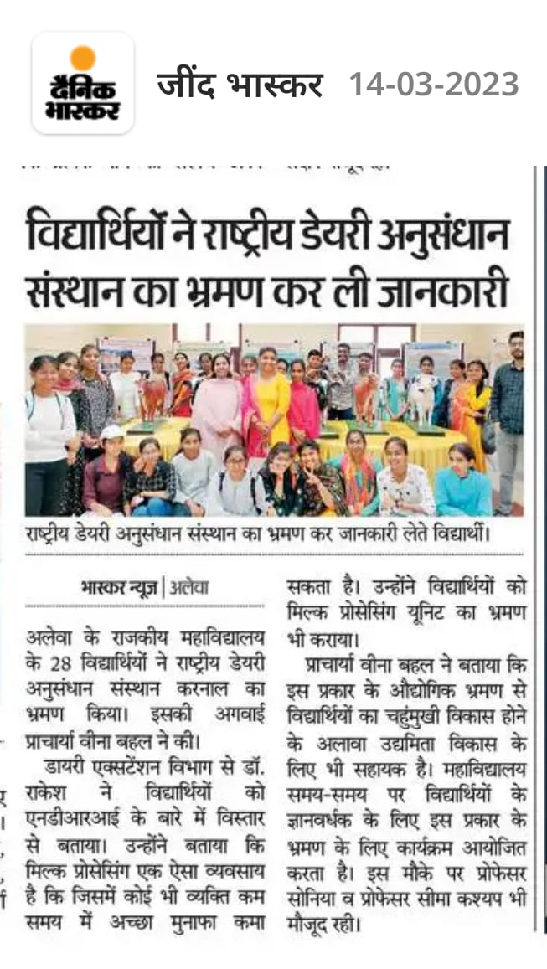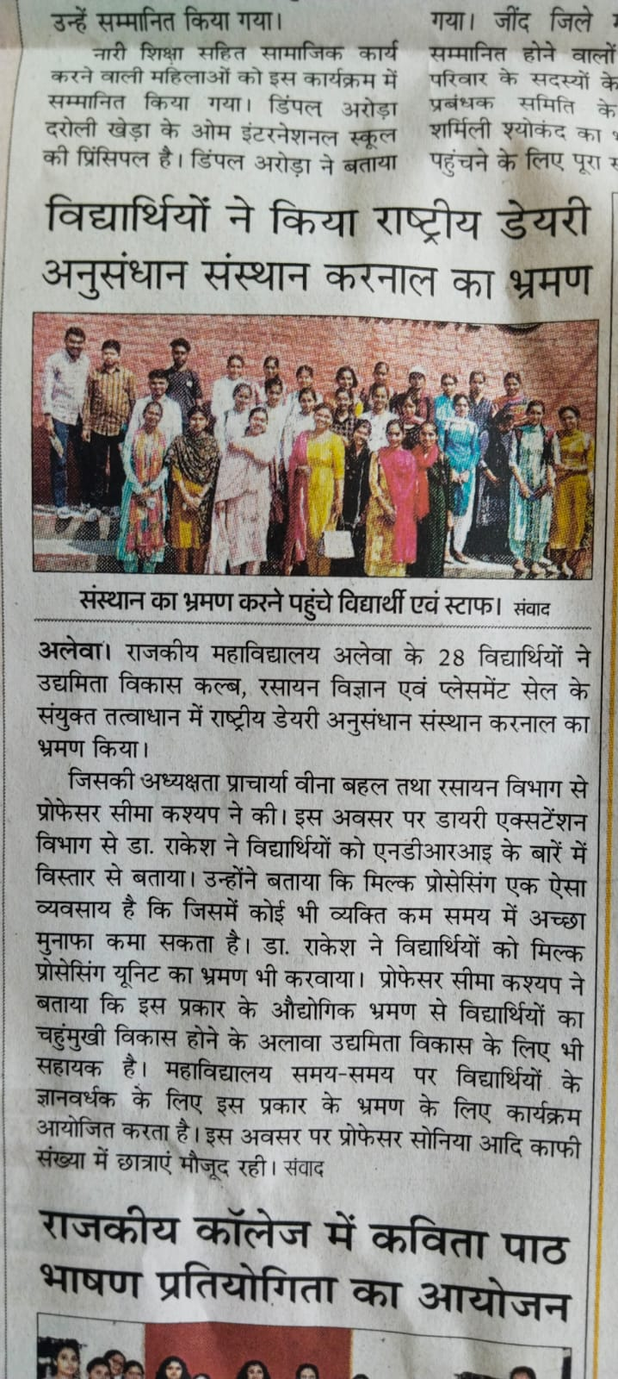

**Report**

**Extension lecture on Quick Math /Vedic Math**

An Extension lecture was organized on Quick Math /Vedic Math for Competition Exams under Placement Cell in Collaboration with NSS Cell dated 21/3/2023. Mr. Sunil Kumar Quick Math Expert delivered the lecture. He gave the information about Short tricks for Mathematics For Example Calender, Time etc, Total 93 Students attended this lecture. The Students were very keen for this lecture. During this lecture, Ms. Seema Kashyap Placement cell Incharge, Dr. Sandeep Sharma, & Other Staff members were also present

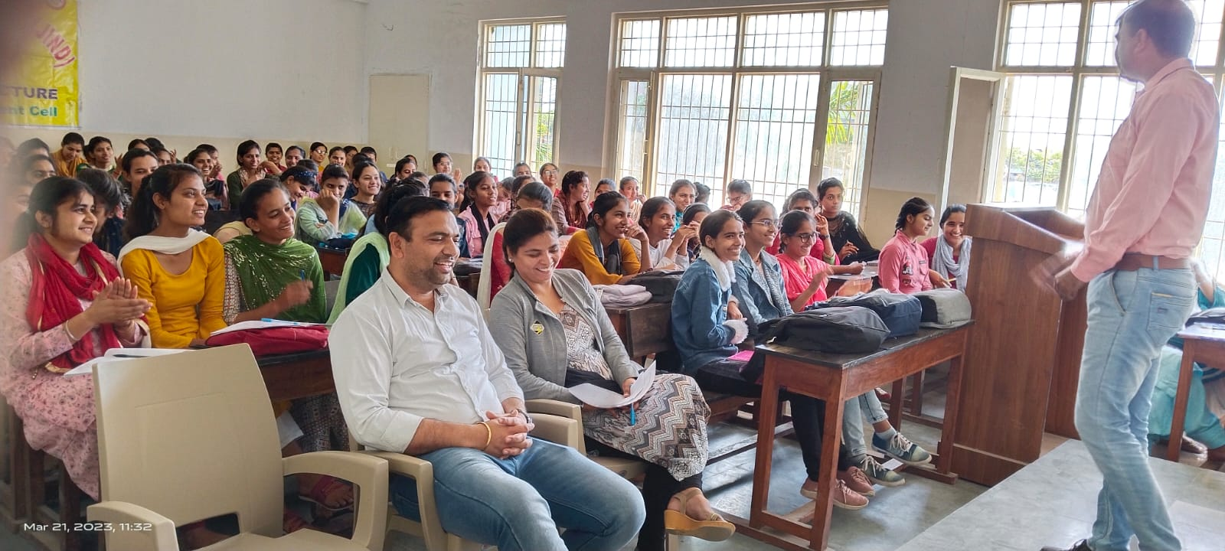 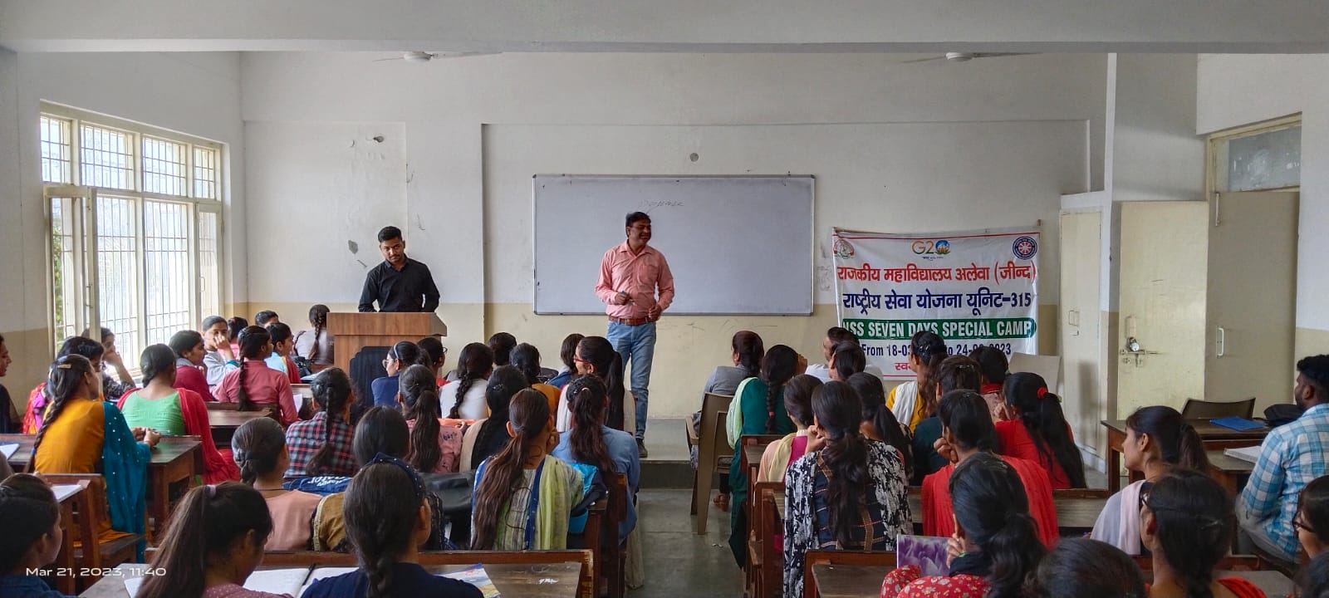

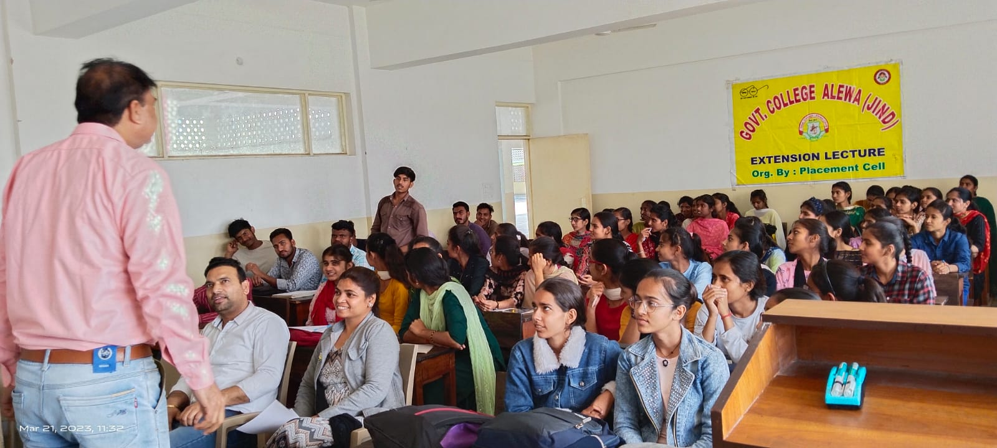

**Report**

**Placement Drive**

**( V Dart Group )**

Participated in Placement Drive of V dart group Hiring Students for HCL Organized by CR.SU Jind. 12 students got benefit from this Drive, All the Students participated in Discussion & Group Interaction. Kajal & Rimpy Shortlisted in this round & face the HR Interview Kajal from B.Sc III Comp.Sci. got Selection in final round . It was a learning & Wonderful Experience for the Students

**Report**

**District level Placement Drive**

**(Govt. College Safidon )**

Participated in District Level Placement Drive Organized by G. C. Safidon in Collaboration with Department of Higher Education Medha Learning Foundation & Job Sarthi. Total 14 Students got benefit from this Drive. Six Studentents Shortlisted in a First Round & got selection. It was Learning & Wonderful Experience for the Students

Press note

**Report**

**Lecture on My Next Exam.com portal**

A lecture-cum-workshop was organised on My Next Exam.com Portal on 22/01/2020. in this Assistant Professor Seema Kashyap informed the students about this portal. how to navigate this site, to create an account, and how to reach the various links provided in this portal. At the end of lecture feedback of students were taken

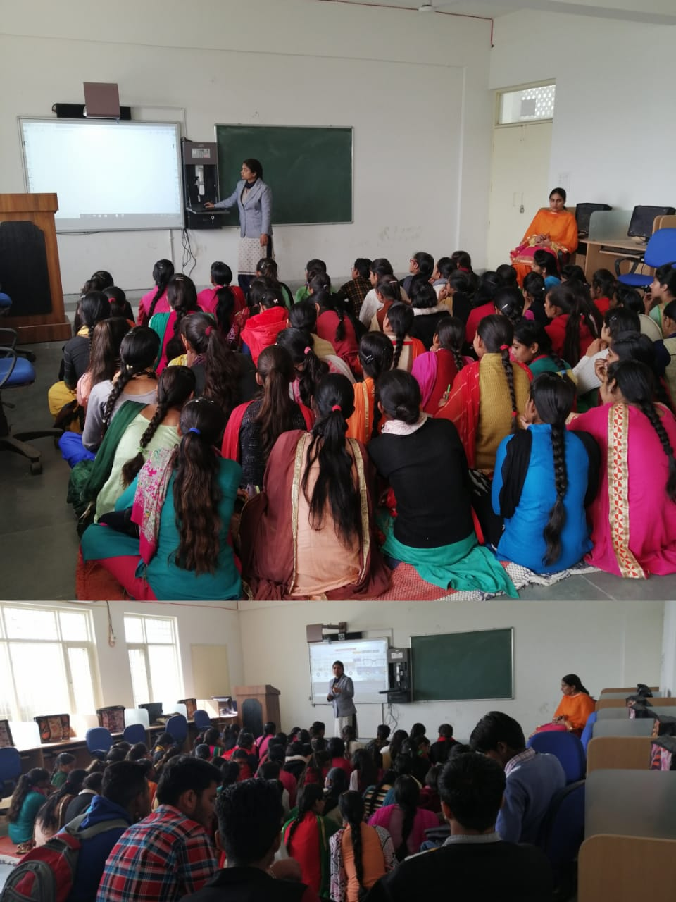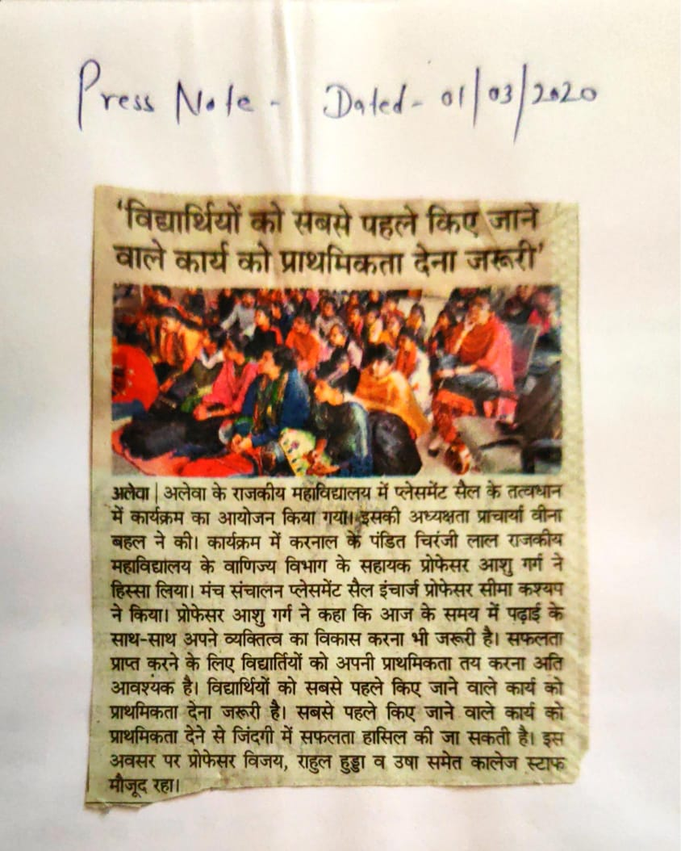

v