**Report**

**Extension lecture**

**Topic – उद्यमिता एवं स्वरोजगार संभावनाएं और चुनौतियाँ**

An Extension lecture was Organized on उद्यमिता एवं स्वरोजगार - संभावनाएँ और चुनौतियों under Placement Cell elated 18/10/2013 . Shri Kuldeep Punia delivered the lecture. He gave the information about the MySBA Swavalambi Bharat Abhiyan, Its main goal is to provide the Employment to each & every citizen & to motiuate the students for Start up. Total 68 Students attended this lecture The Students were very Keen for the lecture. During this lecture Ms. Seema Kashyap, Mrs. Sonia & Other Staff members were also present**.**

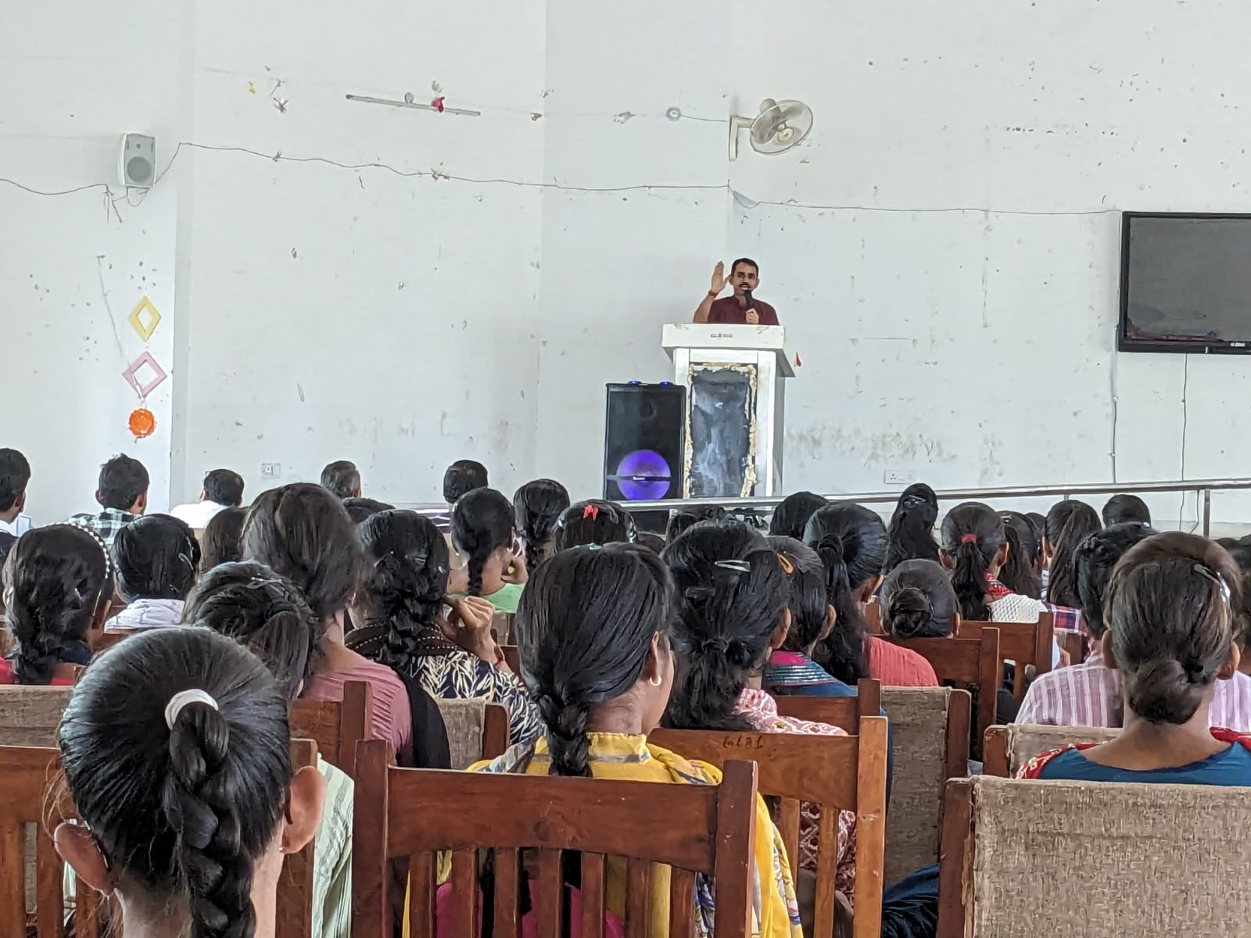

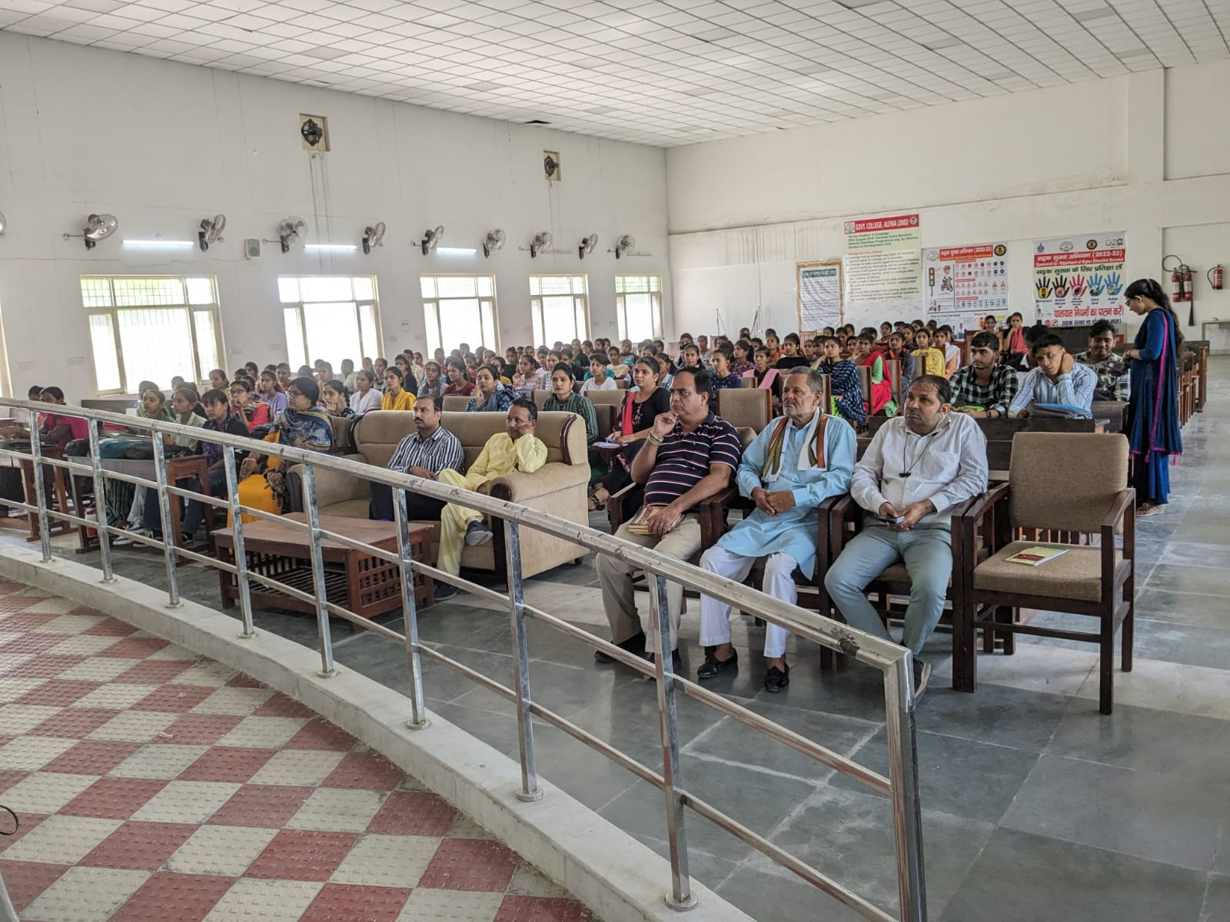

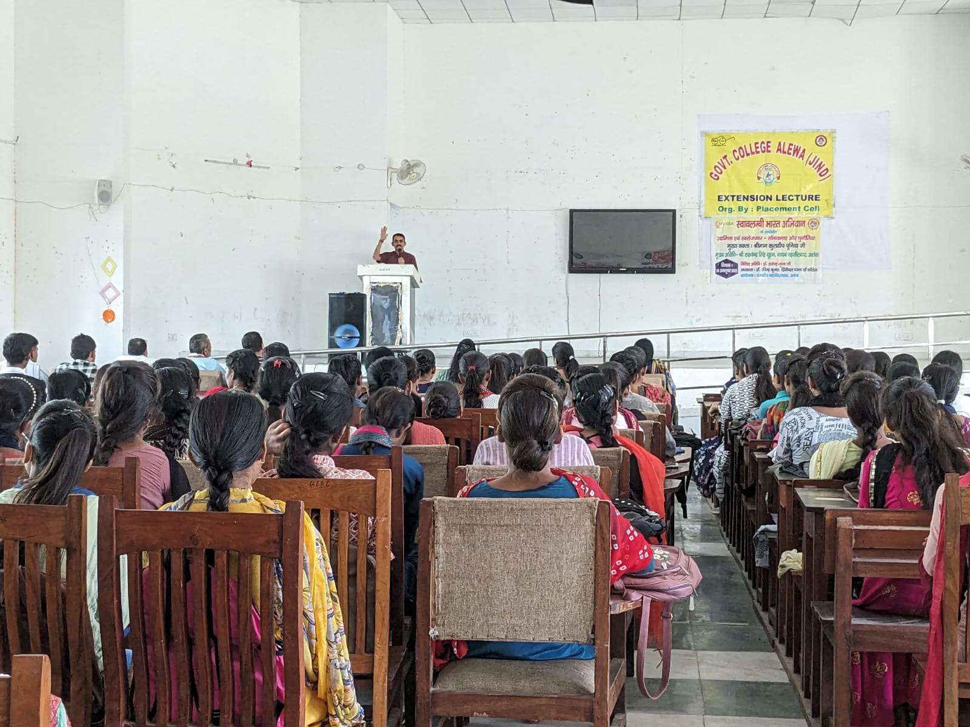

**Report**

**Extension lecture on Life Skill**

An Extension lecture was organized on Life skill under Placement cell dated 01/12/2023. Mr. Naresh Jaglan, Psychlogist under Rehabilitation Council of India, New Delhi delivered the lecture. He gave the information about Importance of life skills & their requirement in your Career & Placement. He says that life skills enable the Individual to translate knowledge, attitudes & Values ​​into actual abilities. He says that Educational qualification & Employability skills have nothing to do regular problems arise in the work place, Which can be effectively Handled with Knowledge & the application of Life skills. It was Extremely informative Session. The Students Show active participation. Total 53 Students attended this lecture. During this lecture, Ms. Seema Kashyap, Placement Cell Incharge, Dr. Sonu Jangra, & Mrs. Soniya were also present

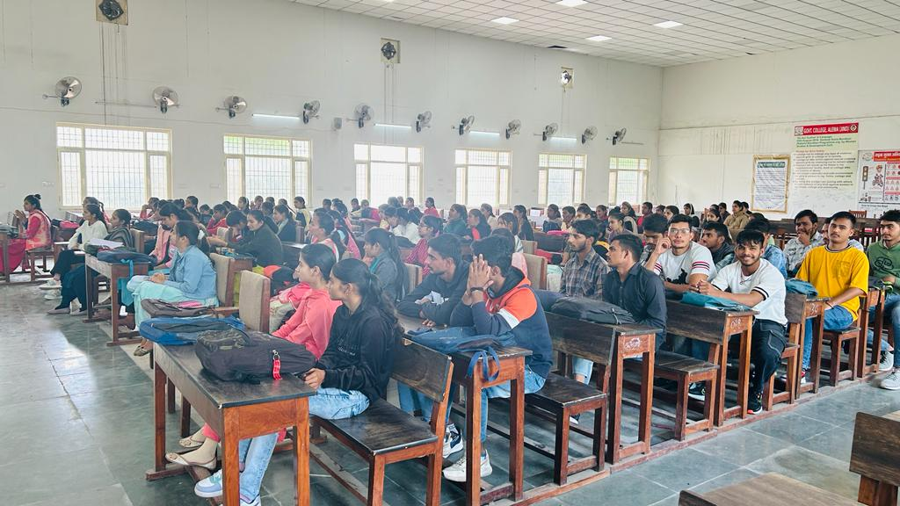

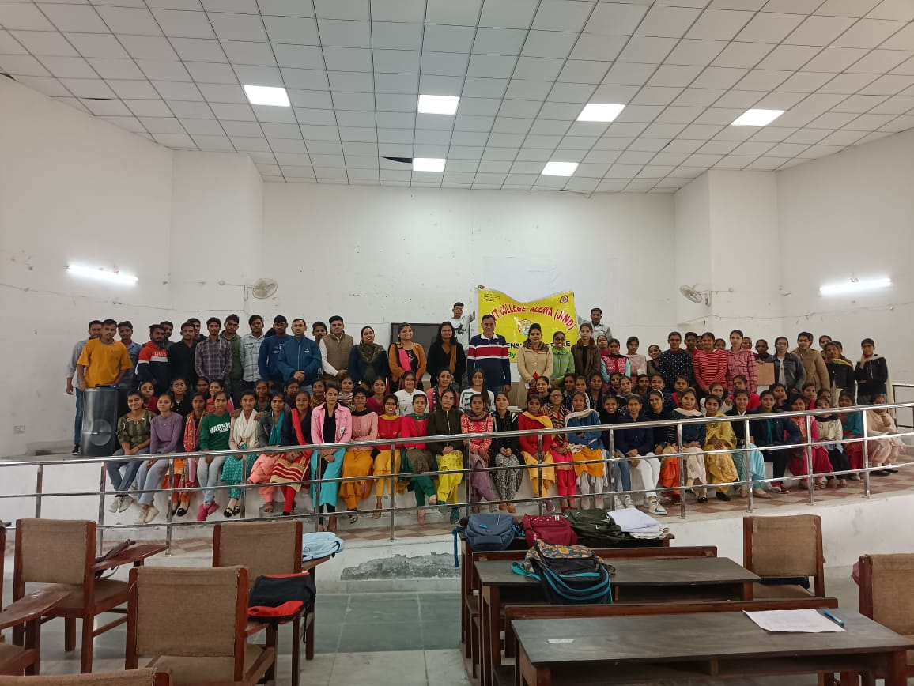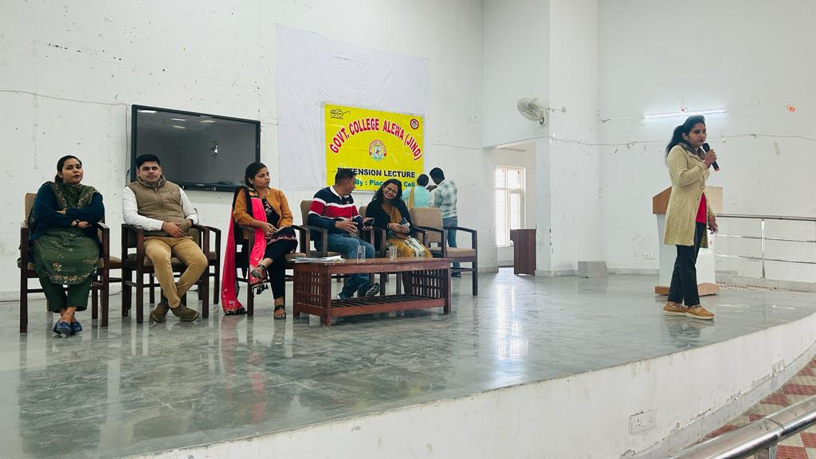

**Press note**

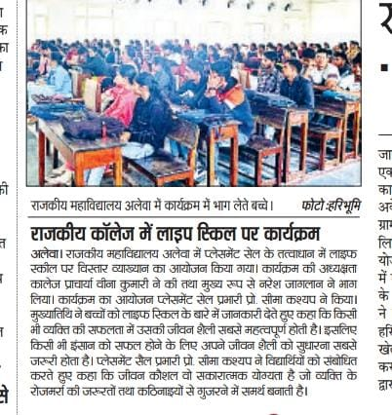

**Report**

**Extension Lecture**

**Topic - Pathway to Competition Exam preparation**

**&**

**Career opportunities in the field of foreign language**

Two Extension lectures were organized on Topic Pathway to Competition Exam preparation & Career opportunities in the field of foreign languages under Placement cell dated 02/12/2023. Dr. Kamal Kumar, Assistant Prof. in Department of Tourism & Management, Pt. C.L.S. Govt. College Karnal delivered the lectures. He discussed about the Job opportunities in different field of foreign languages. He said that Pursing a Career in foreign languages opens up various Job opportunities including language Specialist Translators, Interpreters & language Analysts are in demand in Various Sectors including government agencies, multinational Corporations & the Media. In Today's Competitive Job Market, being bilingual for multilingual) can be a Crucial differentiating factors. Many Employers actively seek Candidates with language skill's to fill positions that involves international travel, Client Management or Global operations. It was Extremely informative Session. Total 52 Students attended this lecture.

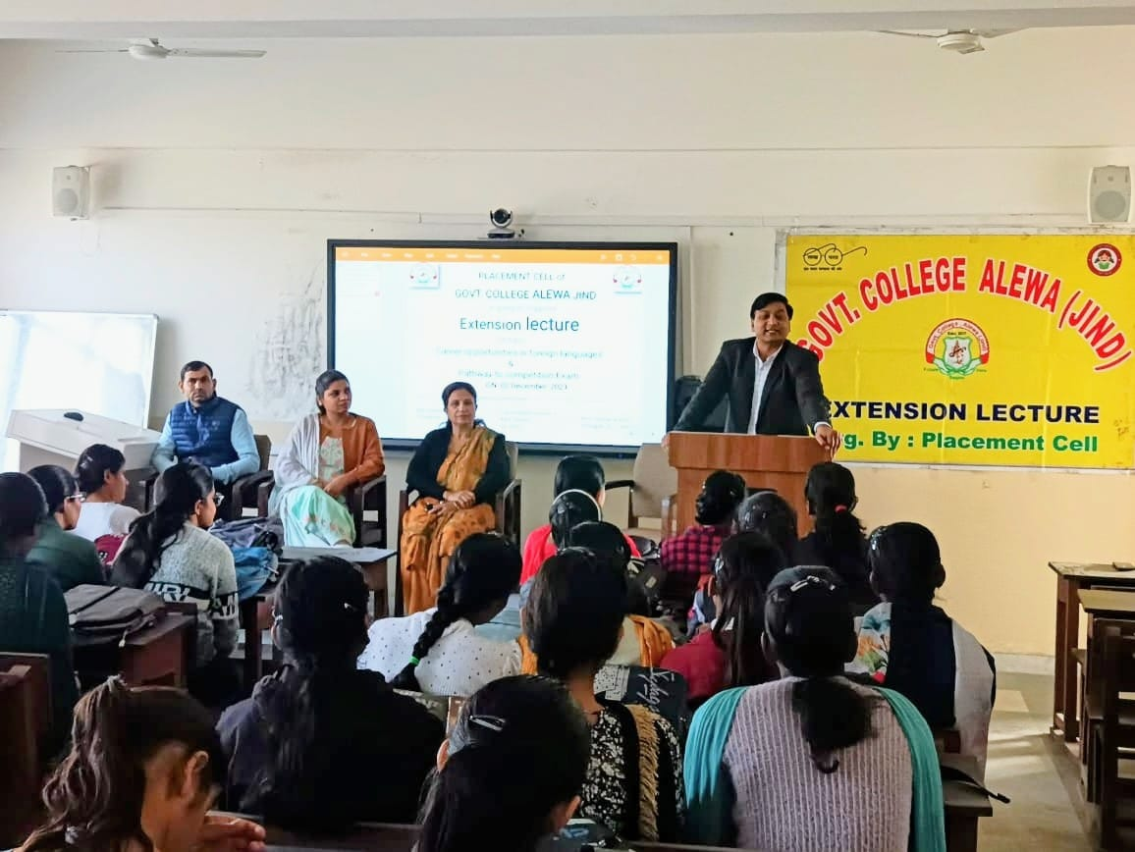

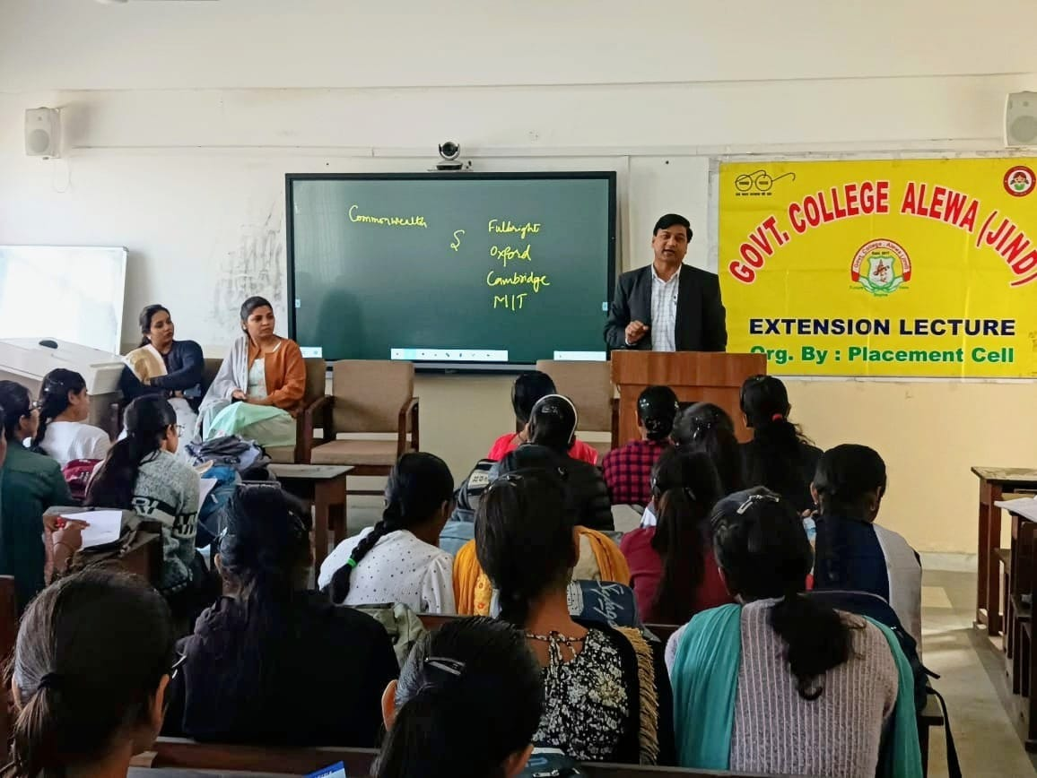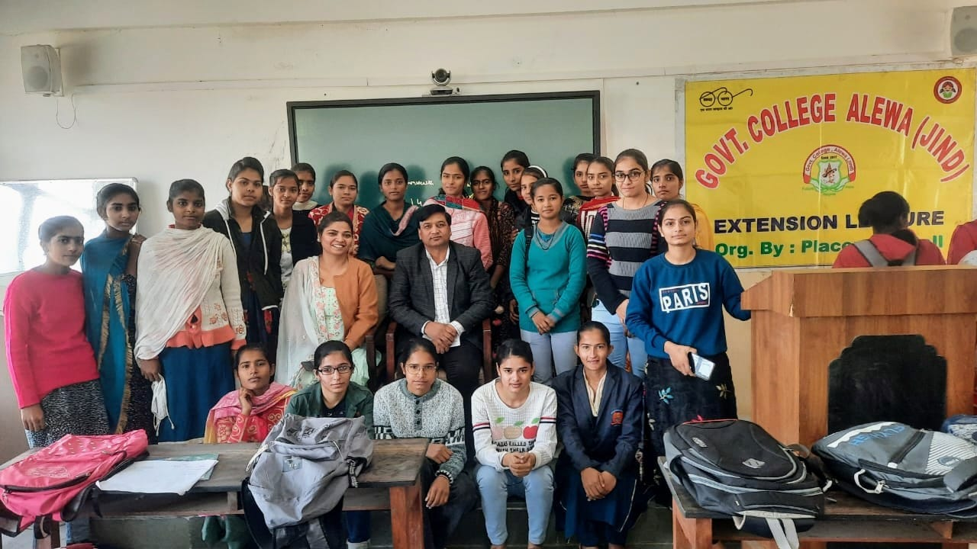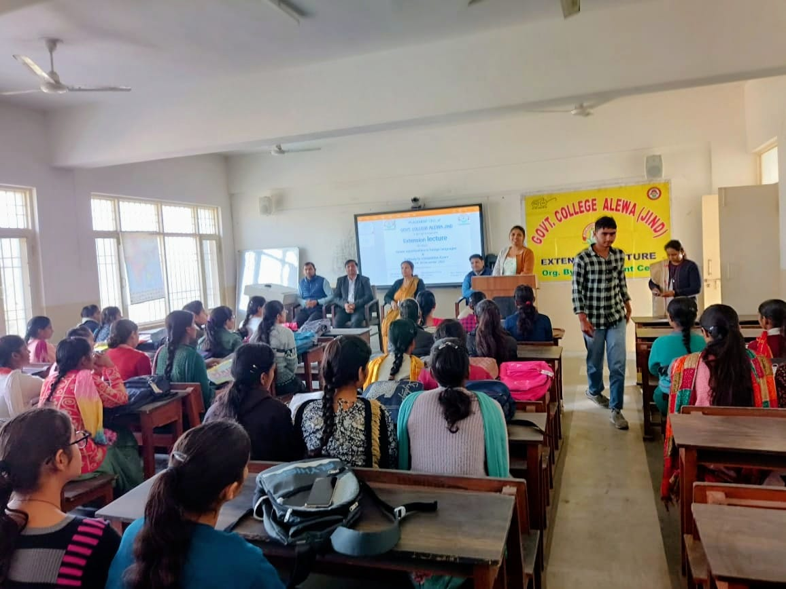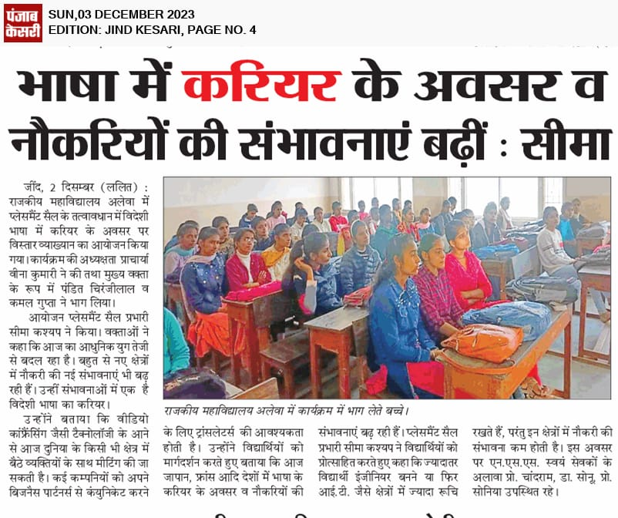

**Press note**

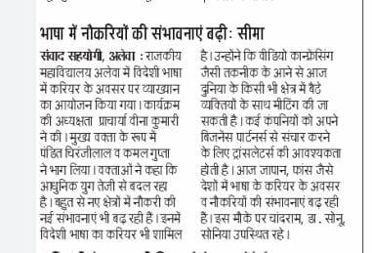

**Report**

**Extension Lectures**

**Topic - Communication Skills**

**&**

**Career Counselling**

Two Extension lectures were organized on Communication Skills & Career Counselling under Placement cell dated 04/12/2023. Mrs Dipti Assiptant profession, Department of Commerce from Deshibaridhu Gout College Panipat delivered the lectures. While delivering the lectures, She Said that Effective Communication is Important for Career Success. As Leaders who Create a Culture of positive Communication can help business reach their goals. With Greater efficiency, they Can Create Employee. While Satishfred addressing the students. Placement coll Incharge, Ms. Seema Kashyap Said that skills do-not mean Communication only Verbal & writing skill. This includes the etiquette & manners of the applicant The students show Active participation in this Total 50 Student participated in thip lecture. During this lecture, other faculty Members were also present. =

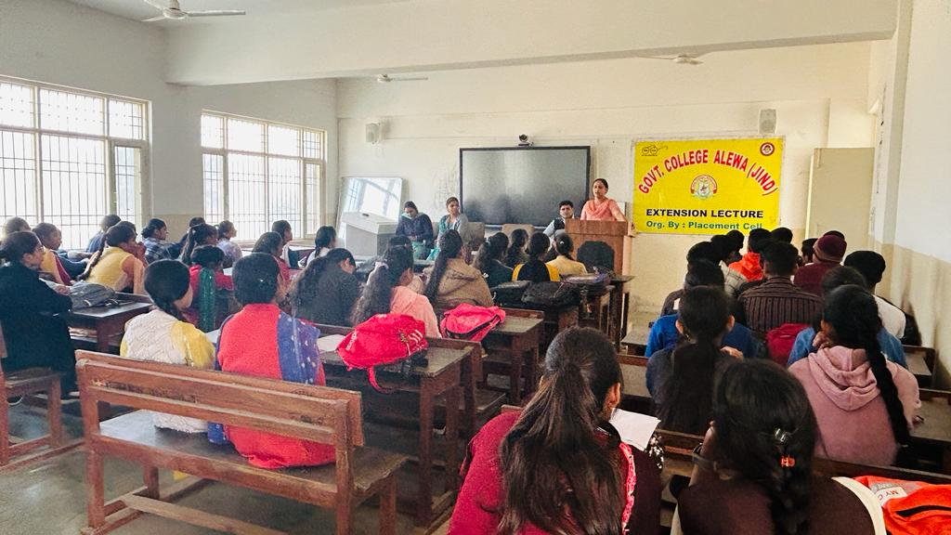

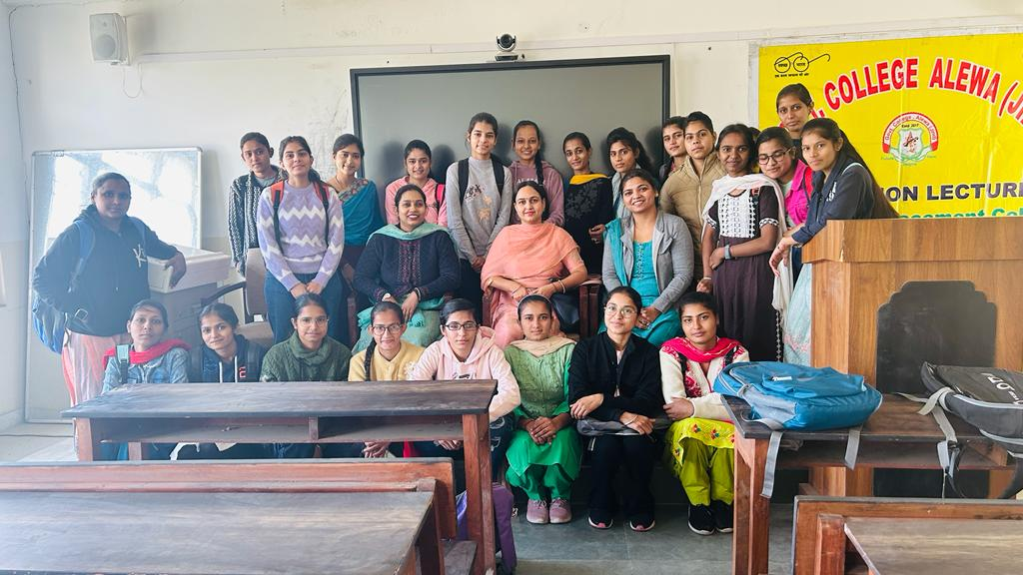

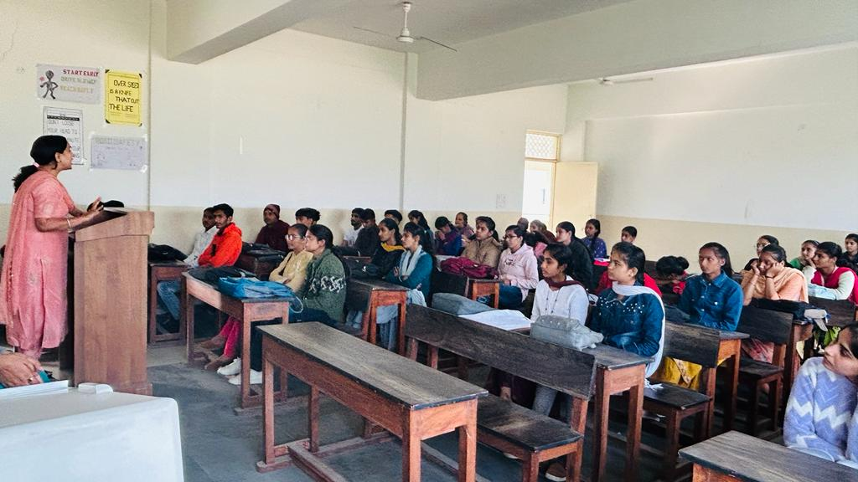

**Press Note**

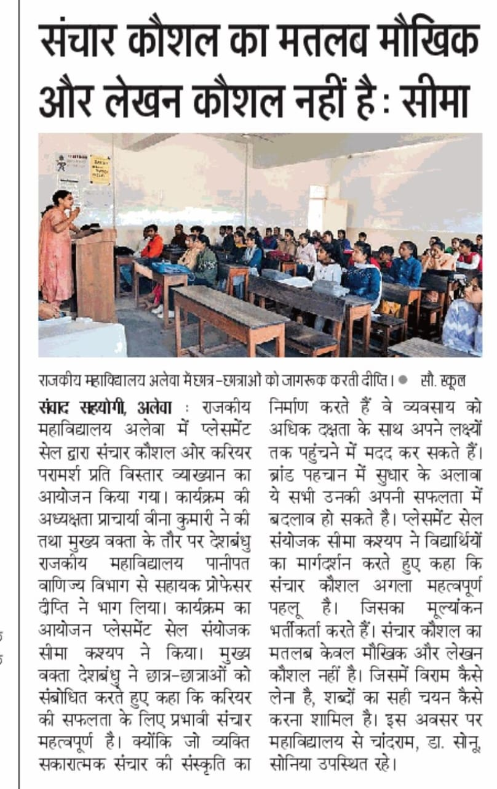

**Report**

**Job Utsav**

**(CRSU Jind in Collaboration with Nandi foundation)**

Participated in Job utsav in CRSU Jind Organized in Collaboration with Nandi foundation dated 30/1/2014. 12 Students got benefit from this Job Utsav. Total 6 Students got placement in pranav vikash & FIEM Industries Ltd. It was a Learning & Wonderful Experience for the Students. It provides the direct interaction with Industry professionals It prouide a platform for the Student to practice & refine their job seeking skills**.**

**Placement Details**

|  |  |  |  |
| --- | --- | --- | --- |
| **Employer Name** | **Student ID** | **Student Name** | **Class** |
| Pranav Vikash | 24315 | Kusum | B.Com-III |
| Pranav Vikash | 26073 | Kajal | B.Com-III |
| Pranav Vikash | 24192 | Preeti | B.Com-III |
| Pranav Vikash | 26076 | Pooja | B.Com-III |
| FIEM Industries Ltd | 24263 | Suniti | B.Sc -III |
| FIEM Industries Ltd | 24237 | Tannu | B.Sc -III |

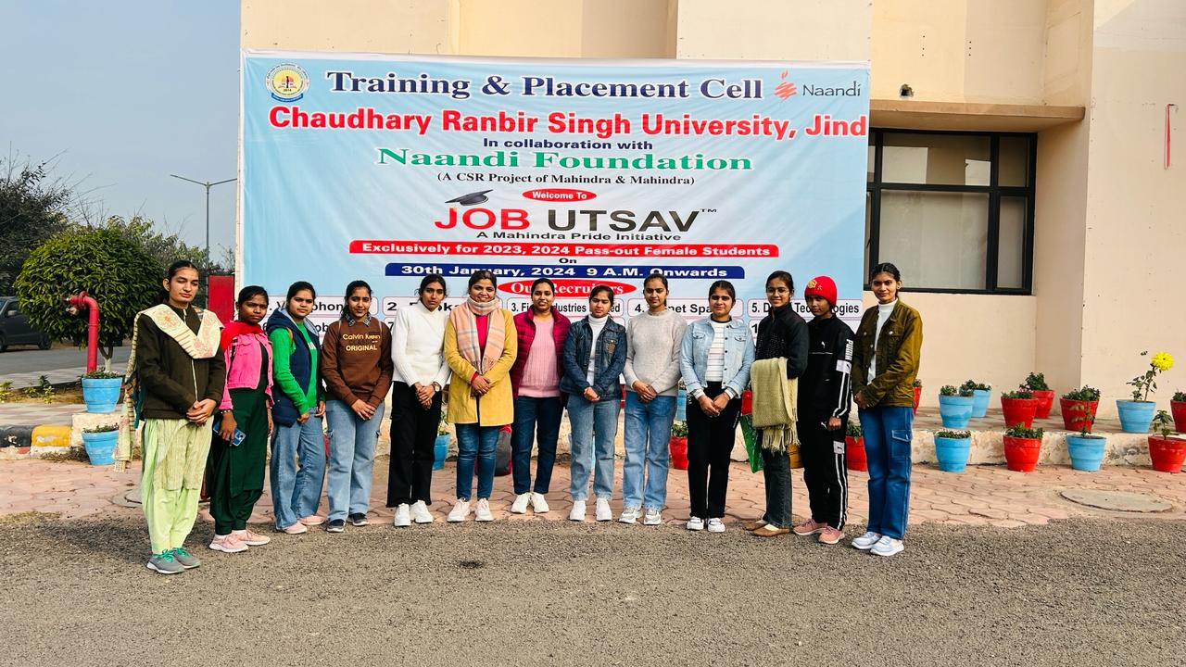

**Report**

**Placement Job Fair**

**( Pt. N.R.S. Govt. College Rohtak)**

Porticipated in Placement Job Fair in Pt. N.R.S. Govt. College Rohtak dated 31/01/2024 Total 12 Students got benefit from this Job Fair. It was a learning & Wonderful Experience. It provides the platform for the Students to practice & refine their Job Seeking skills. Total 4 Students got offer Letters. Ms. Seema Kashyap & Mrs. Sonia accompanied the Students during this Job Fair.

**Placement Details**

|  |  |  |  |  |  |
| --- | --- | --- | --- | --- | --- |
| **Employer Name** | **Student Name** | **Class** | **Roll No** | **Job Role** | **Salary** |
| Pukhraj | Abhishek | B.Sc -III | 1210661015011 | Wellness Advisor | 120000/- |
| Pukhraj | Paras | B.Sc -III | 1210661015022 | Wellness Advisor |  |
| Event Badshah | Isha | B.Com-III | 1210661003008 | Executive |  |
| Event Badshah | Amisha | B.Com-III | 1210661003007 | Executive |  |
| Kotak | Amisha | B.Com-III | do | Advisor |  |

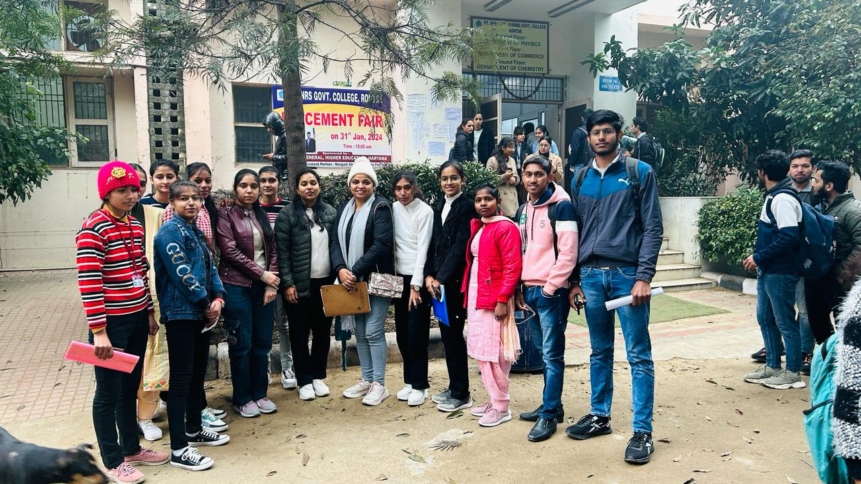

v